Pinewood Derby Ideas

www.shac.org/pinewood-derby-theme

If you find these resources helpful, or have comments or additional resources we can add, please let us know by contacting darlene.scheffler@gmail.com.

- How to Conduct a Pinewood Derby: https://www.scouting.org/training/adult/supplemental/pinewood/
- Pinewood Derby Rules: https://boyslife.org/hobbies-projects/pinewood-derby/157283/official-rules/
- Event Tips: https://scoutingmagazine.org/2015/12/20-tips-planning-hosting-best-pinewood-derby
- Event Tips: https://blog.scoutingmagazine.org/2015/12/15/10-tips-for-planning-the-best-pinewood-derby-ever
- Make a Fast Car: https://boyslife.org/hobbies-projects/projects/2952/speed-secrets/

Content  (Sources: Baloo’s Bugle: The Great race, BSA: The Great Race,  https://voiceofscouting.org/online-roundtable-january-2016  http://pack798.org/Documents/Pinewood%20Derby%20documents/General/Miscellaneous/Activities%20Booklet.pdf  Ideas:  Cheers  Meeting Handout  Gathering Activities  Opening Ceremonies  Invocations  Poems  Audience Participation  Advancement Ceremonies  Songs  Run-ons & Jokes  Skits  Games  Cubmaster Minute  Closing Ceremonies  Decorations  Social Media Posters  Theme Related Stuff  Placemats | Placemats  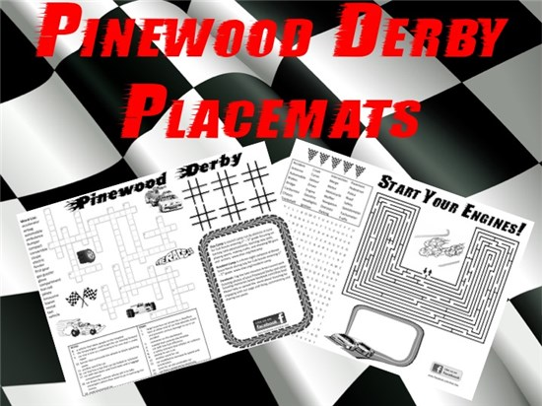  Free, customizable placemats are available to use at the pinewood derby to help promote day camp. Download placemats at  www.shac.org/pinewood-derby-theme.
Pinterest

Find additional ideas visit the SHAC Pinterest page, at www.pinterest.com/samhoustonbsa/pinewood-derby.

CHEERS

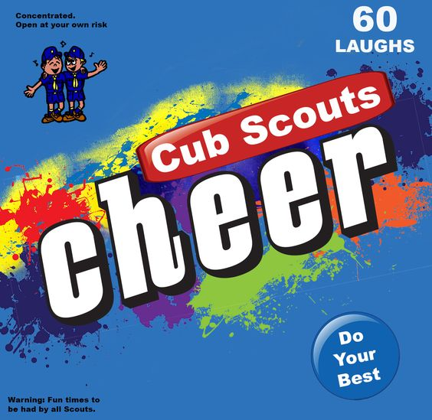
Cheers add fun to meetings and campfire programs. Use cheers during Cub Scout den meetings, pack meetings, or campfires. The cheer graphic can be printed and attached to a blue bag or a box wrapped in blue construction paper. Stuff the cheer box with themed cheers written on strips of paper before each meeting. Someone (e.g., assistant Cubmaster) should be assigned to jump up and enthusiastically lead cheers throughout the meeting (e.g., after a skit or advancement ceremony). Download the graphic at www.shac.org/Data/Sites/1/media/resources/leader-guides/Cheer-Box-1200x1170.jpg.

Applause stunts are a great way to recognize a person or den in a pack meeting for some accomplishment they have performed. Be sure before you start that everyone knows and understands the applause stunt and how to do it. Applause stunts serve more than one purpose -- they not only provide recognition but also help liven up a meeting. Applause stunts need to be fun. Strive for quality of performance in your stunts. Another important side effect of Applause stunts is they provide” wiggle time” for all the Scouts and siblings during the ceremonies so they sit still during the serious moments. It is a lot easier and a lot less stressful to lead a cheer and have fun than to be constantly reminding the Scouts to sit quietly.

Print: Cheers and Applause's (cut into strips and put in Cheer box)

Checkered Flag Cheer: Wave one arm in figure-eight motions.

Construction Flagger Cheer: Wave your arms and yell “Slow down!”

Dip Stick Applause – Pretend to check the oil in your car and yell, “You’re a quart low.”

Harley Cheer - Get on your motorcycle, Kick start a couple of times saying, Vroom Vroom Then give it the GAS and drive away.

Model T Cheer: Push your nose with one finger and say, “Beep, beep!” Make a fist, push your arm out, and say, “Honk, honk!” Then push your stomach and say, “Ah-you-gah, Ah-you-gah!”

Pinewood Derby Cheer 1: “Let’s give ourselves the pinewood derby car cheer.” “Vroom” (quietly). “Vroom!” (louder). “VROOM!” (LOUD!)

Pinewood Derby Cheer 2: Hold your hand over your head and bring it down as if it were a car coming down the track while saying, “Swooooooosh…..” then “Yay!”

Pinewood Derby Cheer 3: Hold your right hand over your head and bring it down as if it were a car coming down the track, while going “Whoosh,” then “Thud” as it hits the bottom and end of the track.

Pinewood Derby Cheer 4: Move hands like a racer and say “ZOOM” 3 times.

Pinewood Derby Cheer 5: Cubmaster yells, ‘Start your engines,” Everyone places their car at the top of the ramp (they raise their hands up in the air, fingers straight, palms down) Then the cars go down the ramp Everyone moves their hands in the shape of the track going “Whooooosh” all the way It all ends as the car hits the bumper at the end Everyone gives one big, loud clap

Pinewood Derby Winner Cheer: (To recognize a particular person) Do as above, but at the end, yell out “ is the winner!!! (Repeat three times)

Pop A Wheelie Cheer - Pop wheelie leaning way back and saying, “EERRRRTTT!”

Race Car Cheer: Move hand forward like a race car moving down a race track and shout “V-V-R-R-o-o-o-m!” Or shout "ZZZRRRrrrrrrOOOOOOOOOOOOMMMMMM"
Do it three times (at least!)!!

Squeaky Wheel Cheer: Hold out your arm, and bend at the elbow. Make a motion like a wheel and say, “Squeak, squeak, squeak!”

Trucker Cheer: Pretend you are driving a big rig. Reach above your head and pull the horn cord, make a loud, deep “HONNK! HONNK!”

VROOM Cheer: Make a sound like a car revving up and say, “Vroom, vroom!”

GATHERING ACTIVITIES

Race Car Neckerchief Slides
Materials: Each slide requires one half of a clothespin, two beads, markers or paint, plastic rings or PVC pipe, and glue. As each Cub Scout arrives, give them the pieces to make their own race car neckerchief slide. Direct them to a table where they can assemble and decorate the slide.
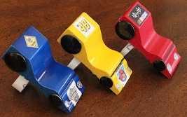

Road Sign Game
Road signs like these are important to drivers. Can you think of some games that can be played to help you learn the signs (e.g., dominoes, Bingo)? Hide the signs around your meeting area and then have the Cub Scouts find them and mark them off on a card.

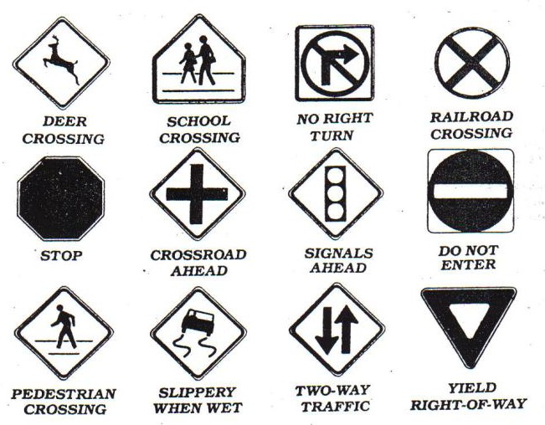
Do You Know Cars?
Each of the definitions below describes a car. Can you name them? (May need your parents' help, some are no longer manufactured!)
- Our 16th President?
- River in New York?
- First Colony in New England
- Indian Chief
- Theater in which Lincoln was shot
- A spotted horse
- A hawk
8. A motherless calf
9. A wild horse
10. One who travel and finds new things
Answers
1. Lincoln; 2. Hudson; 3. Plymouth; 4. Pontiac; 5. Ford; 6. Pinto; 7. Falcon; 8. Maverick; 9. Mustang; 10. Explorer

Transportation Quiz
- A form a transportation that does not run on wheels is .
Skateboard Snow-mobile
Blade skates Tank
- The inventor of the wheel is unknown, but the first record of a wheeled vehicle goes back 5,000 years to ancient .
Babylonia Sumer
Egypt Greece
- The wheel is a form of a simple machine called the
Pulley Wedge
Screw Lever
4. The earliest wheels were made of .
Joined wood slabs Bronze Chiseled stone
Iron
- The first important improvement in construction was the wheel.
Wire Disk
Welded Spoked
- A major improvement in the wooden wheel was (An iron rim Harder wood Flat area elimination Axle lubrication
- Starting with the 13th century, a person who made and repaired wheels was called a
Wheelwright Wheelie
Wheeler-dealer Wheelsman
- Around 1830, a new kind of wheeled vehicle began to appear, the .
Steamboat Stanley steamer
Shaftmobile Steam locomotive

Answers: (1) Snowmobile (2) Sumer (3) Lever (4) Joined wood slabs (5) Spoked (6) An iron rim (7) Wheelwright (8) Steam locomotive

OPENING CEREMONIES

Car Show
Seven Cub Scouts hold up the letters to spell, “CARSHOW.” The fronts should have the letter. The back should have their part in large letters. One at a time have them read their part.
C – Cub Scouts
A – Are
R – Ready
S – to Show
H – How
O – Our Cars Go!
W – Welcome. Please join me in the Scout Law.

Cars & Wheels
Welcome to our Pack Meeting. Our theme is Cub Scout Car Show and probably just about all of you arrived on some sort of wheels. Wheels have given us a great freedom to move about our neighborhood, our town, our state, and this great country of ours. However, with that freedom comes an equal responsibility. We have to use our wheels safely. Car wheels, bicycle wheels, scooter wheels, skateboard wheels: all come with different responsibilities and safety rules. Car drivers should obey the speed limit. Bike riders need to obey road regulations when riding, and pedestrian regulations when walking their bikes.
In the same manner, the Declaration of Independence and the Constitution give all citizens certain rights, but with those rights, come responsibilities. Let’s all stand and say the pledge to the flag of our great nation.

Destination Cub Land
People: Six Cub Scouts with speaking parts and two Cub Scouts holding the bus
Props: Large cut out cardboard bus with open windows or windows set as flaps from which a Cub can stick out their head
Set Up: Have two Cub Scouts walk onto the stage carrying a cardboard cutout of a bus. Have the six Cub Scouts with speaking parts walking along on the side of the bus away from the audience. As their turns occur the Cub Scouts stick their heads out of the windows.
# 1: Ladies and gentlemen, the destination of this bus is Cub Land. It’s an attraction which offers more than Disneyland, Kings Island, and television combined.
# 2: When you get to Cub Land, you will find fun and crafts projects to make
# 3: You’ll find games and songs.
# 4: Cub Land has great treats such as weekly den meetings and trips.
# 5: Each month there is fun filled pack meetings with awards, skits, and songs.
# 6: Webelos Scouts in Cub Land work on exciting Adventures and visit troops. (Proceed with a patriotic ceremony).
Great Race Opening
Nine Cub Scouts hold nine posters with letters that spell “GREAT RACE” when put together. Their lines are written in large print on the back of the posters. The Cub Scouts start with their backs to the audience; each one turns around before saying their line.
G – Get ready now.
R – Racing is fun.
E – Everyone join,
A – And soon someone has won!
T – Try your best.
R – Really, do!
A – All Cub Scouts,
C – ’Cause it’s the great race,
E – Extra fun for me and you!
All nine Cub Scouts together: Welcome to the pack meeting, Let’s have a GREAT RACE!

A History of Transportation
Materials: Narrator and 6 Cub Scouts with a model or picture of the following: Foot, wheel, boat, engine, airplane and rocket.
# 1: (foot) Man learned to get from place to place, running set a faster pace.
# 2: (wheel) Then he invented the wheel to show how much further he could go.
# 3: (boat) The boat helped us carry more. Now we travel from shore to shore.
# 4: (engine) Engines helped us travel far. Almost everyone owns a car.
# 5: (airplane) On airplanes we travel fast. The jet age has arrived at last.
# 6: (rocket) Rockets fired into space, have taken us past the moon’s face.
Narrator: Transportation has changed our lives and so have the vehicles used. These vehicles play an important part in our lives, either taking us places or bringing us goods and services. Cub Scouting is also a vehicle. It takes us places by inspiring us to look for new adventure outside our homes.
And just as cars and engines need fuel to go, so do we. We need new ideas, new incentives, and new opportunities. Trains, planes, buses and ships need crews to keep them going. We do to. We need our parents and leaders to work together to keep the dens and pack going. I’m glad you are on board. We have a wonderful ride in store for you.

Models for the Future
The Cubmaster shows a model of a futuristic car and says: Cub Scouts, here is a great looking car. It is the builder's vision of what cars may look like in the future. We can't be sure that he's right. But we can be sure that the world is going to need good men in the future. And we can be sure that we will all be good men if we remember to follow the Scout Law. Let's remember that as we stand and repeat the Scout Law.
(could make a great Cubmaster's Minute)

Piece of Wood
Equipment: Piece of wood, item carved out of wood
CM: (holding up piece of wood) This is a plain piece of wood, but with imagination we can make many things from it. This is also true of a Cub Scout. From the beginning, you learn many skills in Cub Scouting that will make you a better person.
CA: (holding up item carved out of wood) This is carved out of a plain piece of wood to become something beautiful. We hope to carve a Cub Scout into an adult who is a responsible citizen. You help us to this by learning about citizenship, love of country, and love of God as you advance through each rank.
CM: Please stand and say the Pledge of Allegiance with me.

Pinewood Derby Opening
Race flags—A preassigned den can assist with this. Have one flag of each color—the flags can be made of paper, fabric, felt, etc. Have one Cub Scout as the narrator, and one Cub Scout for each flag who will step forward with their flag and recite the line(s).
Narrator: “Flags have had many uses throughout our history to communicate information. Colored flags used in auto racing can be an example of how we travel through life.”
# 1: “Green—This flag signals the beginning of our race—we can go as fast as we dare, trusting there are no obstacles to get in our way.”
# 2: “Yellow—This flag signals caution—we need to slow down and continue cautiously.
Danger may lie ahead.”
# 3: “Red and yellow stripes—This flag means a barrier is ahead with debris on the track!
We sometimes meet challenges in life. A trustworthy Scout meets these barriers and overcomes them to race ahead cautiously but surely toward the goal.“
# 4: “Red—STOP! There IS danger ahead. We must stop and rethink our plan before moving forward.”
# 5: “Black—Sometimes in a race, mistakes are made. We all make mistakes, but a trustworthy racer admits the mistake, corrects it with the help of the members of their team, learns how to avoid that mistake, and gets back out on the track.”
# 6: “White—There is only one lap to go. The goal is up ahead, so we stay the course to reach the finish line.”
# 7: “Black-and-white checkered—WE DID IT! We finished the race. We didn’t give up and did our best.” (This flag should be waved enthusiastically.)

Pinewood Derby Opening
(could be a Cubmaster's Minute)
If you take a moment tonight to contemplate these cars, you will realize that an awful lot of painstaking work went into each one. There is much creativity and ingenuity represented here. I don't know, but I imagine that each car was designed to be the fastest. Of course, not all cars will win. As we begin our pack meeting, keep in mind that in Cub Scouting, as in life, the victors are those who put forth earnest effort. As a great marathon runner from Kenya, a country in Africa, once said "To win is to finish. To finish is to win." Please join me in the Pledge of Allegiance.

Pinewood Derby Opening
Have eight Cub Scouts hold up the letters to spell, PINEWOOD. The front (toward audience) should have the letter and an appropriate picture. The back (toward the Cub Scout) should have their part in large letters. One at a time, in order, have them read their part.
P A Pinewood Derby is fun for all, but the whole family must answer the call.
I I will enter the competition real soon. To win or lose or whatever my doom.
N Neatly I painted my car with dad's expert help, But please let me run it all by myself.
E Excitement runs all though the night, No matter who wins, it will be alright.
W We would all like to come in first, But if not, our bubble wouldn't burst.
O On with the races, don't hesitate, For this Pinewood Derby can't wait.
O Open the gates, down the track; then we can rest. For, being Cub Scouts, we've done our best.
D Don't mind tonight, where your car places; Cub Scouting will help you through all life's races.

Pinewood Derby Opening
Nine Cub Scouts hold up large cardboard cutouts of derby racers. Each one has a letter on it to spell Derby Time.
D Dads and sons this month have had some fun.
E Everyone working to make the Pinewood Derby Run.
R Races will be held right here tonight.
B Boys and girls hoping they built theirs just right.
Y Yearning to win a race or two.
T Thinking about the competitions cars must go through.
I In just a short while the races will begin.
M May all the very best cars win.
E Everybody now please rise as the pledge to our flag we say.
Thus declaring Pack ___'s pinewood derby underway.

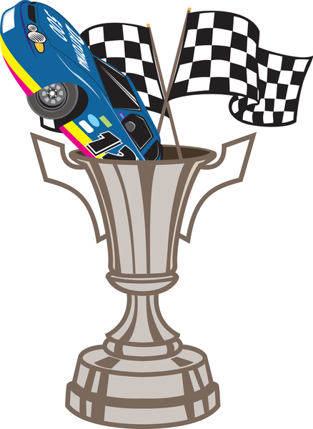

Racing Flags Opening Ceremony
Announcer: Our opening ceremony tonight is to show you the use of the colored flags in auto racing! Colored flags similar to those used to show their color meaning in an actual race. Checkered flag is made from white crepe paper sheet using black stripes. All other flags are made of plain crepe paper. Each Scout carries a flag and waves it during their part of the opening.
#1: (carries pack flag) Gentlemen, your attention please! All cars in the race on the track, now!
#2: (carries green flag) Once around the track and then we will start. Watch that green flag.
#3: (carries yellow flag) All cars running well, looks like we're off to a good start. Whoops! A spinout on the back of the track! Slow down and hold your places!
#4: (carries red flag) Watch out for the spinout - another car is hit - driver on the track. Stop the race! We have a driver on the track!
#5: (carries green flag) The track is all clear - all cars back in racing position. Let's have another start. Watch that flag!
#6: (carries den flag) There is another spinout on the track! That guy hit the wall. Doesn't he know he can't win a race that way?
#7: (carries a white flag) Here comes lucky number 2! They are still in first place! Looks like we have a winner!
#8: (carries checkered flag) It's number 2! A checkered flag for the winner. Well folks, that's our mock race - now let's get on to the real one!

Simple Block of Wood Opening (or Skit)
Characters: Each Cub Scout holds a cardboard figure in front of them starting with a square block of wood. Cub Scout 2 is roughed out pinewood derby racer. Cub Scout 3 is a racer with a little paint. Cub Scout 4 and 5 are the finished cars.
Setting: Each Cub Scout walks on to the stage to read their part. The last Cub Scout runs onto the stage shouting their line.
# 1: I'm only a simple block of wood,
Cut from a tree so tall.
Unlike the tree that thundered down,
No noise would I make should I fall.
# 2: But in the hands of a wide-eyed Cub Scout,
Armed with a knife and a saw.
There are many shapes that I can take,
Some wide, some short, some tall.
# 3: A little paint, a line or two,
Nothing fancy, but not too plain.
No two alike, made with loving hands,
We are all of the tree that remains.
# 4: Like each little Cub Scout's life,
Starting with form.
Like a block of wood cut from a tree,
The loving hands of leaders like you,
Help us each to be what we shall be.
# 5: And I'm gonna be a racer!

Sportsmanship
Equipment: Cards with letters S-P-O-R-T-S-M-A- N-S-H-I-P on the front and the script on the back in large print.
CM: Tonight, we will have our pinewood derby.
S Smile, even if you hurt inside
P Plan to have a good time
O Only use kind words
R Respect the feelings of other Cub Scouts
T Try your best
S Speak positively of others
M Master the art of self-control
A Anger has no place in our meeting
N No pouting
S Success in “doing your best” is possible for every Cub Scout
H Hush those words of bragging
I Inappropriate comments and actions are not welcome
P Participate in the derby for FUN!
CM: Let’s remember the word SPORTSMANSHIP throughout our Pinewood Derby tonight. Please stand and repeat the Pledge of Allegiance.

Things That Go
Cub Scouts line up and hold their posters up as indicated below. On the front (facing audience) is the appropriate picture. On the back in large print is the script for the Cub Scout to read.
# 1: (word "GO") Wheels, wings, and rudders make many things go, All invented by men I'm sure you all know.
# 2: (Model-T Ford) Henry Ford was an important man, for he helped invent n car, He made it in mass production, and made it to go long and far.
# 3: (Spirit of St. Louis plane}"'Lindberg was a man whom we've all read about, He helped build a plane that made the world all shout.
# 4: (Steamship) Robert Fulton did his part in making something that would go, The steamship made him famous, about steam he sure did know.
# 5: (Steam Engine) James Watt, too, became famous, for something that would go, His improvements on the steam engine, year after year did grow.
# 6: (Large wheel with the word "THANKS" for spokes) So you see men such as these, make our country grow, And we're thankful to them, for inventing things that go.
# 7: (U.S. map) So, as we're thinking about the men who have made our nation go, Let us now salute the flag, ever thankful for all that we know.
# 8: Will the audience please rise. Those in uniform, salute. Those not in uniform, place your hand over your heart. Please join me in the Pledge of Allegiance.

Wheels Opening
Props: Each Cub Scout has appropriate clothes or gear to illustrate their line.
CM: There are a lot of ways to have fun with wheels. Let's see a few in action:
# 1: I have fun riding my bicycle.
# 2: I like to go rollerblading.
# 3: Trains are my thing.
# 4: A go-cart is the vehicle for me.
# 5: Riding cross country in a truck is my type of fun.
CM: As you can see there are many ways for Cub Scouts to have fun with things that have wheels. Trains and trucks are more than just fun, though. They are all important in the development of our country. Let's stand and honor their inventors as we say the Pledge of Allegiance.

INVOCATION

Prayer
Lord, help us to have fun and be good sports whether we win or lose in the great race. Help us remember as Cub Scouts to always do our best. Thank you for our families who guide us on this path. AMEN.

Gilbert's Pinewood Derby Prayer
by Peggy Porter http://usscouts.org/usscouts/pinewood/gilbert.asp

Gilbert was eight years old and had been in Cub Scouts only a short time. During one of his meetings he was handed a sheet of paper, a block of wood and four tires and told to return home and give all to "dad". That was not an easy task for Gilbert to do. Dad was not receptive to doing things with his son. But Gilbert tried.

Dad read the paper and scoffed at the idea of making a pine wood derby car with his young, eager son. The block of wood remained untouched as the weeks passed.
Finally, mom stepped in to see if dad could figure this all out. The project began. Having no carpentry skills, dad decided it would be best if he simply read the directions and let Gilbert do the work. And he did. Dad read aloud the measurements, the rules of what Gilbert could do and what he couldn't do. Within days his block of wood was turning into a pinewood derby car. A little lopsided, but looking great (at least through the eyes of mom).

Gilbert had not seen any of the other kids' cars and was feeling pretty proud of his "Blue Lightning", the pride that comes with knowing you did something on your own. Then the big night came. With his blue pinewood derby in his hand and pride in his heart he headed to the big race.
Once there this little one's pride turned to humility. Gilbert's car was obviously the only car made entirely on his own. All the other cars were a father-son partnership, with cool paint jobs and sleek body styles made for speed.

A few of the Cub Scouts giggled as they looked at Gilbert's, lopsided, wobbly, unattractive vehicle. To add to the humility Gilbert was the only boy without a man at his side. A couple of the Cub Scouts who were from single parent homes at least had an uncle or grandfather by their side, Gilbert had "Mom".
As the race began it was done in elimination fashion. You kept racing as long as you were the winner. One by one the cars raced down the finely sanded ramp. Finally it was between Gilbert and the sleekest, fastest looking car there.

As the last race was about to begin, this wide eyed, shy, eight-year-old asked if they could stop the race for a minute, because he wanted to pray. The race stopped, Gilbert hit his knees clutching his funny looking block of wood between his hands. With a wrinkled brow he set to converse with his Father. He prayed in earnest for a very long minute and a half. Then he stood, smile on his face and announced, 'Okay, I am ready."
As the crowd cheered, a boy named Tommy stood with his father as their car sped down the ramp. Gilbert stood with his Father within his heart and watched his block of wood wobble down the ramp with surprisingly great speed and rushed over the finish line a fraction of a second before Tommy's car. Gilbert leaped into the air with a loud "Thank you" as the crowd roared in approval.

The Scoutmaster came up to Gilbert with microphone in hand and asked the obvious question, "So you prayed to win, huh, Gilbert?" To which this young boy answered, "Oh, no sir. That wouldn't be fair to ask God to help you beat someone else. I just asked Him to make it so I don't cry when I lose."

Children seem to have a wisdom far beyond us. Gilbert didn't ask God to win the race, he didn't ask God to fix the outcome; Gilbert asked God to give him strength in the outcome. When Gilbert first saw the other cars he didn't cry out to God, "No fair, they had a father's help". No, he went to his Father for strength.
Perhaps we spend too much of our prayer time asking God to rig the race, to make us number one, or too much time asking God to remove us from the struggle - when we should be seeking God's strength to get through the struggle.

Gilbert's simple prayer spoke volumes to those present that night. He never doubted that God would indeed answer his request. He didn't pray to win, thus hurt someone else -- he prayed that God supply the grace to lose with dignity. Gilbert, by his stopping the race to speak to his Father also showed the crowd that he wasn't there without a "dad", but His Father was most definitely there with him. Yes, Gilbert walked away a winner that night, with his Father at his side.

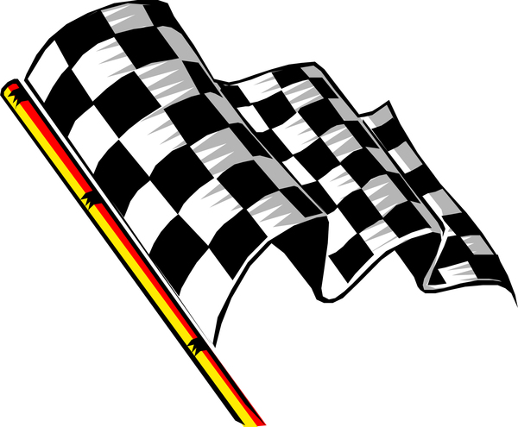

POEM

Pinewood Derby Reading
When I make my car,
I hope that I can win.
Everything is ready,
the weight & shine & spin.
The first race is the real test,
to see how good it is.
My helper is happy too,
you'd think the car is his!
Eventually I lose a race,
and it is hard to take,
But my helper and I sure had fun,
a pinewood derby car to make!

The Poem
'Twas the night before pinewood,
his car still needed lead,
he had done his very best,
when his mom yelled "Get to bed!"
He climbed under his blanket,
his car wasn't ready to race,
the pinewood derby was tomorrow,
there was a frown on his face.
Just as his eyes closed,
he heard something spin,
it was Scout Saint Nick,
coming to help him win!
As he peeked from under the covers,
Scout Saint Nick started to drill,
to help his car speed,
on its way down the hill.
He splashed on some paint,
and stuck on some wheels,
he put the car on its stand,
and clicked his boot heels.
This woke the young scout,
he had a smile on his face,
a happy Pinewood to all,
and to all a good race!

AUDIENCE PARTICIPATION

Big Race (Audience Participation)
Narrator reads the following like a radio announcer with a lot of enthusiasm!
Divide audience into four groups. Assign each a word and a response they are to say when that word is read. Practice as you make assignments.
WHITE = Whiz!
RED = Zoom!
YELLOW= Zip!
BLUE = Ca-Chunk!
TIE = All stand and cheer
The cars are ready. The flag us up.
The race is set to go. The flag goes down, The cars are off...
They're running toe to toe! The WHITE car is ahead. The RED car goes by.
Here comes the YELLOW car now. Here comes another one - it's BLUE. Whew, it sounds bad, wow!!
The last lap now.
The RED car is leading,
The YELLOW car and WHITE car are close behind. I'm looking hard — I see the BLUE car.
So far back, it's hard to find! The finish line is just ahead.
That BLUE car is coming up fast, I can't tell why ...
The crowds on its feet... They're yelling -
The WHITE car, the RED car,
The YELLOW car, and the BLUE car,
HAVE ALL FINISHED IN A TIE!!

Big Wheel
Divide the audience into four groups assign each group a word and a response when that word is read. Practice the responses as you make assignments.
Big Wheel = Spin, spin
Canoe = Paddle, paddle
Airplanes = Zooooom
Cars = Rattle, rattle, bang, bang
Caution - There are a lot more Big Wheel(s) in this than the other parts. Maybe you would want to make it that ALL respond when Big Wheel(s) is read.

Man has invented may different things which go and have provided him with transportation down through the years. The Indian made his CANOE which took him from place to place and served his purpose well. Men like Henry Ford invented CARS which today are the most popular type of transportation. There were men like the Wright Brothers who pioneered the invention of the AIRPLANE. And then there is a group of people called the BIG WHEELS who really don't go any place or do anything, but they like to feel important.
This story is about one of those BIG WHEELS who just sat and spun his wheels and felt so important while he was doing nothing at all. Everyone around him was working on new and better types of CANOES, designing new and more efficient CARS, and designing and testing new and faster AIRPLANES. But our BIG WHEEL just sat around feeling important, not doing anything to help anybody, while everyone else was doing the work.
Somehow he always seemed to get by and fool people into thinking that he was important because everyone around him was making progress. The BIG WHEELS depended on their brains and energy to make him look good. Finally, one day something happened that changed things overnight for the BIG WHEELS.
Everyone who had been working on the CANOES, the CARS, and the AIRPLANES decided it was time to teach the BIG WHEEL a lesson. They were tired of him doing nothing except acting important. So they all became very busy and didn't pay any attention to him. When something came up, the BIG WHEEL found he couldn't rely on the others to answer questions and make him look important. Finally, the BIG WHEEL realized that he could not accomplish anything without help from others. He realized he was making no contribution to the world at all. He was just sitting there spinning his wheels while the others accomplished a lot of CANOES, CARS, and AIRPLANES. BIG WHEEL felt very bad.
It was a terrible feeling when BIG WHEEL finally realized something he should have known all along. If you're going to get any place in this world, you can't expect other people to do all the work. You must learn to do your part and drive your own CAR, fly your own AIRPLANE, and paddle your own CANOE.

The Great Race
Divide the audience into six groups. Assign each group a part to perform when their designated word appears in the story (which you should read like a radio announcement, with a lot of enthusiasm):
White = “Whiz!”
Red = “Zoom!”
Yellow = “Zip!”
Blue = “Ca-Chunk!”
The cars are ready. The flag us up. The race is set to go. The flag goes down. The cars are off—they’re running toe to toe!
The WHITE is ahead. The RED goes by. Now here comes the YELLOW. Here comes another one—it’s BLUE! Whew, that sounds bad. Wow!
The last lap now. The RED is leading. The YELLOW and WHITE are close behind. I’m looking hard—I see the BLUE. So far back, it’s hard to find!
The finish line is just ahead. The BLUE is coming up fast, I can’t tell why. The crowd is on its feet and yelling. The WHITE, the RED, the YELLOW, the BLUE have all finished in a tie!

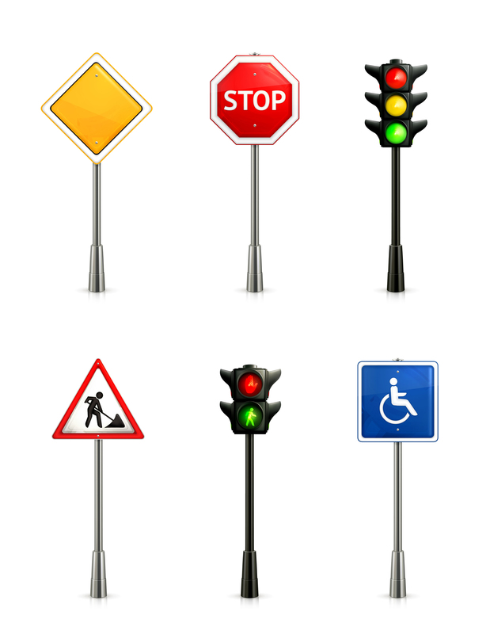

Go-Cart Derby
Divide audience into three parts. Assign each group a phrase and an action to do when they hear that phrase. Practice.
DOWN THE HILL “Zoo-oo-oo-mmmmmmm”
THE STRAIGHT AWAY “Swooo-oo-sshhh”
AROUND THE CORNER “Zip-zip-zip”
In a small town in the mid-west every year, there was held a big go-cart derby for all the Cub Scouts in the town. This event was planned for many months in advance and was looked forward to with much anticipation by all the Cub Scouts. The Cub Scouts and their parents worked for months on building go-carts that would race DOWN THE HILL coast beautifully on THE STRAIGHT AWAY and go AROUND THE CORNER
like winners. Each family worked hard to see if theirs could be the top winner in the derby. All over town, you could see the go-carts being tested DOWN THE HILL, THE STRAIGHT AWAY and AROUND THE CORNER.
One day, as they were making their test runs before the big race, one little Cub Scout named Johnny discovered that if he went DOWN THE HILL, AROUND THE CORNER , he would
run farther THE STRAIGHT AWAY before his cart came to a stop. He had found the ideal spot for the race. After trying it several times, he hurried to tell some of the parents about this spot, hoping that they would hold the Derby there this year.
Several parents came out and watched Johnny’s go-cart go
DOWN THE HILL, AROUND THE CORNER and on
THE STRAIGHT AWAY. They agreed that this would be a good spot to hold the race, except that Johnny had overlooked one thing – the go-carts were fine going DOWN THE HILL and AROUND THE CORNER, but it was when they came to a stop on THE STRAIGHT AWAY that they had problems. You see, they came to a stop right in the middle of a drive-in restaurant. The parents got together and decided to talk to the restaurant owner. As a result, the owner agreed to close his restaurant during the Derby race and the whole town turned out to watch the go-carts race DOWN THE HILL, AROUND THE CORNER and into THE STRAIGHT AWAY. What a spectacular race it was! After the race was over, everyone decided that, since the restaurant owner had been so generous to close his restaurant during the race that they would all buy their dinner there that night. After all, driving those go-carts DOWN THE HILL, AROUND THE CORNER and into THE STRAIGHT AWAY had made all the Cub Scouts very hungry, and the shouting and cheering done by the parents had helped them work up a good appetite, too. The restaurant owner was happy because he sold more hamburgers than he had ever sold in one day.
An agreement was made with the restaurant owner that every year they would hold their go-cart derby in that same spot, with the carts racing DOWN THE HILL, AROUND THE CORNER and into THE STRAIGHT AWAY to the drive- in restaurant. They would all celebrate afterwards and buy those delicious hamburgers. So, you see, kindness and consideration to others can make things go better for everyone.
Little Pinewood Derby Car
Divide the audience into four groups and assign each group the part that matches their word. As the story is read and they hear the word, they should say their part.
Pinewood derby: “Vroom, vroom”
Trust: “A Scout is”
Someday: “In the future”
Cub Scout: “Do Your Best”
Once upon a time, there was a very young pinewood derby car. His biggest dream was to someday be in a pinewood derby race. Sadly, he was still in the box sitting on the shelf. He was really just a block of wood, some wheels, and some nails. But in his mind he was the fastest, shiniest pinewood derby car that would ever go down the track.
Time after time, excited cub Scouts came into the store and grabbed a box that said “pinewood
derby car” on it. But somehow this little car had been pushed to the back of the shelf where his box was hard to see and even harder to reach.
He thought and he thought about how could he get a cub Scout to notice him. He asked one of the display pinewood derby cars about it. They sat by his shelf with their beautiful paint jobs and racing decals and a sign that said “not for sale.” The car said, “My little friend, you must have trust that you will be picked by your perfect cub Scout and go race at the pinewood derby. It may not be today, or tomorrow, but someday, yes, someday it will happen.” So the little car waited . . . and he waited . . . and he waited. It seemed like forever, but he never lost that trust and knew that someday he would be picked by his perfect cub Scout and race in the pinewood derby. And then the day finally came. A very excited cub Scout ran into the store and straight to the shelf where all the pinewood derby car boxes sat. He was so excited that as he reached for a box, he knocked several of them off the shelf and onto the floor. As the cub Scout stacked the boxes back onto the shelf, he saw the box with the little pinewood derby car way in the back. He reached way, way back and grabbed hold of the box. Somehow he just knew this box held a winner!
At this point in our story, we aren’t sure who is the most excited, the cub Scout or the pinewood derby car.
After some sawing and some painting, and having his wheels put on, the pinewood derby car was ready for his big day, and his cub Scout was even more excited than before.
Once they got to the race, the pinewood derby car was checked in and weighed to be certain he was worthy to race on the track. He knew it would be fine—he had trust that his cub Scout had followed the rules in building him, and would follow the rules while racing. And suddenly it was HIS turn to sit at the top of the track. He was the most excited pinewood derby car you could imagine. As the race started and he zoomed down the track, he saw his Cub Scout waiting for them at the finish line and knew that no matter what happened, he was glad he had sat on the shelf and waited for someday and had trust enough to wait for his perfect Cub Scout.
New Car
Tonight, I’m going to read a little story about a couple that go shopping for a new car. But the story is rather dull. I’d like you to help me make the story livelier by joining in when I read certain words. Whenever I say these key words, please follow these instructions; it’ll help the story a lot!
- If you have blue eyes, whenever you hear the word BLUE pat the top of your head.
- If you have brown eyes, whenever you hear the word BROWN pat the top of your head.
- If you hear the word LEFT and you’re left-handed, clap your hands.
- If you’re right-handed, clap when you hear RIGHT.
- If you’re under 20, stomp your feet when you hear the word NEW.
- If you’re over 20, stomp your feet when you hear the word OLD.
- If you’re a male, stand up when you hear MAN.
- If you’re a female, stand up when you hear WOMAN.
At this point the Narrator should practice with the audience, calling out the cue words having them respond with the appropriate action. The Narrator begins the story slowly and picks up speed Narrator pauses after each key word.

One day a MAN and a WOMAN went looking for a NEW car. Their OLD one, which was a muddy BROWN was not running well. It LEFT much to be desired in the way of speed and safety, and they wanted another one RIGHT away. They wanted a bright BLUE one.
As they walked into the dealership, the WOMAN noticed a BLUE sports car on the showroom floor. “Darling” she said, “Look at that lovely NEW car RIGHT over there. Wouldn’t it be perfect for us?’
“You may be RIGHT. It’s a lot better looking than our OLD BROWN buggy. Unfortunately there’s one problem. I’ve LEFT all my money at home,” said the MAN.
“You LEFT it at home?” asked the WOMAN.
“Yes, it’s RIGHT in the pocket of my NEW BROWN suit.” said the MAN.
“Your NEW BROWN suit? Why I took that suit to the cleaners just this morning and I didn’t notice any money in any of the pockets,” said the WOMAN.
“But I’m certain I LEFT my money in the inside RIGHT pocket of my NEW BROWN suit,” the MAN said as he scratched his head in wonder.
“Now wait a minute. Are you saying I’m not RIGHT? Are you saying I’m lying about this? MAN, oh MAN, oh MAN! You have a lot of nerve!” shrieked the WOMAN.
“Let’s not argue. We’re here to look at cars, and that BLUE one in the corner is a RIGHT nice model. And just think, if we buy the NEW BLUE car, we’ll never have to worry about our OLD BROWN one again!”
After looking at the price of the NEW BLUE-car, and figuring out what they could get as a trade on their OLD BROWN one, the MAN and the WOMAN decide buying a
NEW car would be the RIGHT move for them. But before they LEFT the dealer, they started questioning their decision. Would they be better off with their OLD BROWN car if the NEW BLUE one didn’t run RIGHT? Or what about a NEW BROWN one? How long before they thought of the NEW car as an OLD car? And would they ever feel BLUE about trading in their BROWN auto? BLUE or BROWN, OLD or NEW, what was RIGHT and with which car did they want to be LEFT?
The MAN and the WOMAN were so confused that they decided to sell their car and buy themselves bicycles. And that’s just what they did. And they knew it was RIGHT...LEFT...RIGHT... LEFT (The narrator continues alternating between right and left until the audience realizes they are applauding the end of the story.)

Trouble with the Car
A Mad Libs Reading
30 cards with the following words written on them are shuffled then placed face down on the head table. Cubs line up to pick a card and read it as the Narrator reads the story and pauses for an answer. Cards that are used are kept by the leader, not to be used again.

A Den Leader | A Cub Scout | A Neckerchief
A Roundtable | An Adventure | A Cubmaster
A Webelos Leader | A Year Pin | A Pack Meeting
An Elective | An Arrow | A Patch
A Uniform | A Skit | A Craft
A Game | A Ceremony | A Webelos
A Wolf | A Bear | A KISMIF
A Song | A Den | A Knot
An Oath | An Akela | A Banquet
A Pow Wow | A Pack | A Council

An alternate maybe to randomly assign numbers and have the people read their cards in numerical order.

Once upon a time, my assistant Cub Leader and I decided to drive out of town with our den for a picnic. We loaded a basket with , , and and other tasty things. Then we drove off with our lunch in an old car that belonged to a friend. The cap on the radiator was decorated with and holes in the roof had been patched with and .
As we drive along, my assistant leader pointed to the side of the road. “Oh, look at that bush with and growing on it. Let’s stop here,” she said. We carried the basket to some shade cast by _ and spread out to sit upon. Nearby, sang gaily in a tree and some low bushes had and growing upon them. Our den was having a wonderful time. “There’s nothing as delicious as with mustard and relish,” said our cubs. “Yes,” I sighed. “However, it is getting late. Maybe we’d best start for home now.”
But our car refused to go. The motor made a noise like
and then stopped. “Oh dear,” said our leader, looking under the hood. “I think I see and caught in the gears.” “Impossible,” I said. Are you sure the tank isn’t empty? Are you sure you put in enough before we left home?” “Of course I did,” said our leader. “It must be the wheels. We’ll jack them up with and and then replace them with .” Our leader covered her dress with and took to loosen the bolts.
Just then a former drove up and asked if he could help us. “Looks like in the engine,” he said, tightening a bolt with

with ________. Then he stepped back and the car started. “I just connected _____to , which had rattled loose.” We gave them the rest of our and to show our
appreciation and drive happily home again.

Alternate: This is an audience participation story. As we read the story, each of you, in turn, will pick up a piece of
paper from the front of the room. Each piece of paper has a word written on it. At your turn, you will “enter”
the word in the blank space in this story.

(Note that there are more words on this list that you will need
in the story. This just adds more variety to the story.)
Elephant Carburetor Saw Horse Pencil Peanut Butter
Whale Exhaust Pipe Drill Bell Roast Duck
Pig Horn Saw Gameboy Celery
Buzzard Steering Wheel Axe Baseball Cap Pumpkin Pie
Lizard Trunk Level Bicycle Pineapple
Cow Fuel Pump Shovel Shoe Mashed Potatoes
Lion Ash Tray Screwdriver Coffee Cup Jello

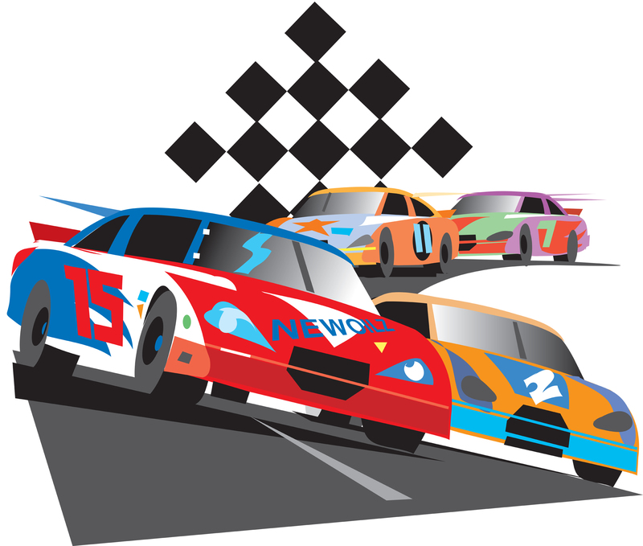

ADVANCEMENT CEREMONIES

Advancement Ideas
Trouble - The Cubmaster and the assistant Cubmaster dress up as a NASCAR pit crew. Announce that they see a Cub Scout car in trouble. Drive over and pick them up and them carry them up front to give them their award. Announce that they are ready to reenter the Cub Scout race.
Remote Control - Have someone hide and drive the awards in with a remote-control car. When it time to present an award it is driven on from off stage.
Here it comes! - Attach awards to a pinewood derby car and send-it down the track to the recipient.
Wheely Proud - Clean out a wheelbarrow. Announce that we are "Wheely proud of our Cub Scouts that have earned awards." Go out into the audience and put them in the wheel barrow and bring them up front to award them.

Car Show Arrow of Light Ceremony
Props: Review the Cub Scout How-To-Book on Cubanapolis 400 racing, Prepare a color or emblem (meaning) for various parts of the car, such as sides, wheels, headlights and tail lights, door, steering wheel, and key. If there is more than one Cub Scout, prepare extra cars and adjust ceremony. Have 4-6 items of information obtained about the Cub(s) ahead of time to surprise them during the ceremony.
Cubmaster - Tonight, we are going to assemble an “Arrow of Light” car. The frame for the car gives it structure and stability. Compare this structure to the requirements needed for the Arrow of Light. The color of the pack “Arrow of Light” car is very important. Give the car some color either the colors/values, emblem, etc. and explain the meaning of the Arrow of Light.
There are lots of things on the inside of a car that helps it to run at high efficiency. I wonder what our “Arrow of Light” car has that helps it run at full throttle? Pull items out of box and display items highlighting the Cub.
Every car has great wheels. Wheels help the car roll down the road. Our Webelos den leader helps our “Arrow of
Light” car roll down the road. We would like our den leader to come share with us an activity/service that helps our “Arrow of Light” car. Den Leader can then put on wheels.
Headlights light the way to move forward and tail lights show us where the car is ahead of us. On our “Arrow of Light” car, we would like the parents to share some service/activity that is unique about their son. Parents then put the headlights and tail lights on the car.
We have a door here. It needs to be put on. The only person who can open this “Arrow of Light” car is . Will Cub share a favorite experience they did to earn the Arrow of Light award and open the door? Cub then puts on door and states the Scout Oath or Law.
This car is about done. We still need two things, a steering wheel and key. On the Steering wheel have the pin and patch. The Cub then gives the pin to their mom with the “Mother’s Salute,” after which, the Father can present the award with the Cub Scout or Scout handshake. The Cub Scout can start the car with the key by leading everyone in their favorite cheer! The Cub Scout can then take their car home.

Checkered Flag
Prop: Checkered flag. I made one from a yard of Checkered Print bought for $2 at a material store. Attach to a pole or dowel.
Presentation: Cubmaster explains that it is customary and traditional for the winner of a NASCAR race to take a victory lap around the course with the flag waving then to come up to the winners’ circle with those who made it possible
for the winner to win. There the winner would be awarded their trophy for the accomplishment. Name the first Cub Scout to receive their rank advancement. Give them the flag and have them run around the outside of the audience with everyone cheering and whistling. After completing the lap have them bring their parents up to the winner’s circle to receive their award. Present the award. Lead a cheer

Grand Prix
Personnel: Cubmaster dressed as a race car driver (e.g., wearing a helmet and gloves and boots), Four adults
Equipment: Four black-and-white checkered racing flags, Four 3-ft. dowels, Toy car, Stop sign, Wheel from toy car
Set Up: Fasten checkered flags to the dowels. Attach awards to the items listed below. Create other awards as needed. Create a tunnel for Cub Scouts to walk through to receive awards by having four adults hold flags.
Awards Sayings
  - CAR: “You zoomed right into first place when you earned your .”
  - STOP SIGN: “Way to go for earning your . There’s no stopping now!”
  - WHEEL: “You’re on a roll now. We’ll (wheel) be proud to award you your .”

Pinewood Derby Advancement

Equipment: Pinewood derby track, attach printout of large rank badges to cardboard, sticks
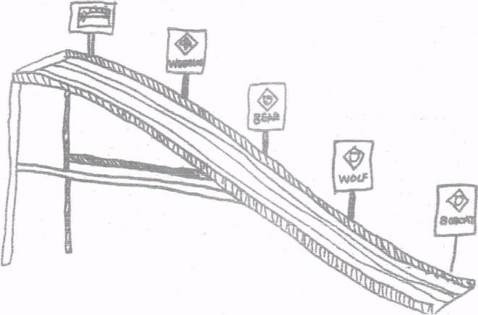
Set Up: Put decals or actual badges on stiff cardboard and attach to eight-inch-long sticks. Tape these on the track or on the side rails of the derby track in ascending order, (Bobcat, if applicable) Lion near the bottom, then Tiger, Wolf, Bear, Webelos, and Arrow of Light. If you have a Cub Scout graduate into a troop, have a Scout Badge at the top. At appropriate place on the track tape the badges and arrow points to be presented. (Fix everything ahead of time so there won’t be a boring time after the derby and before the awards.)
CM - We've all had a great time tonight watching the pinewood derby cars race down this track. They really speed downhill don’t they? Well, you can go up hill on this track too. It is a little harder, but it is worth the climb from Lion to Tiger, Tiger to Wolf to Bear to Webelos Scout and Webelos Scout and to Arrow of Light.
Some of our Cub Scouts have made the climb as far as Bobcat. Will (names) please come forward with your parents. When Cub Scouts and parents have assembled remove their awards from the track and have the parents pin badges on. Congratulate all, thank parents. Lead cheer.
Some of our Cub Scouts have made the next level – Tiger. Will (names) please come forward with your parents. When Cub Scouts and parents have assembled remove their awards from the track and have the parents pin badges on. Congratulate all Scouts, thank parents. (If your pack is awarding Belt Loops for completed Adventures at the pack meeting, present the Tiger ones now. Either before or after the rank award). Lead cheer.
Do the same for the Wolf and Bear badges and their Adventures. Congratulate all Scouts, thank parents. (If your pack is awarding Belt Loops for completed Adventures at the pack meeting, present them now. Either before or after the rank award). Lead cheer.
Have Webelos leader take over for the Webelos badge and Adventures. Remember to congratulate all Scouts, thank all parents, and lead a cheer
And the Arrow of Light Den Leader for those awards. Remember to congratulate all Scouts, thank all parents, and lead a cheer
Cubmster resumes if you are graduating a Cub Scout into the troop.
Pinewood Derby Advancement
Have an unopened pinewood derby car kit box in plain sight, as well as a car drawing, some tools to create a car, a paint bottle, wheels, and a number of finished cars hidden in another box.
Cubmaster: When you first join Cub Scouts, you are like a pinewood derby car that is still in the box. (Raise the unopened kit for everyone to see.) You think about how other Cub Scouts say pinewood derby is cool, but you wonder what’s inside the box and if you can really do this. Den leaders and other adults help you to read the instructions and prepare for the road ahead. These actions are like earning your Bobcat badge, because the trail to Bobcat is all about learning the basics of what it means to be a Cub Scout. Will the following Cub Scouts and their parents please come forward to accept their Bobcat awards?
Tiger den leader: You’ve figured out what you need to do with the things in the pinewood derby box, but now you have to actually put a plan together. You draw a sketch of what you want your car to look like (hold up the cardrawing). A parent may help you figure out how to make that happen. This start of the adventure is just like being a Tiger. You’re learning some of the fundamentals of Cub Scouting and you’re having some fun, but know much more is yet to come. Will the following Cub Scouts and their parents please come forward to accept their Tiger awards?
Wolf den leader: You’re starting to gain some momentum and you know that you will soon start working with tools (hold up a tool that might be used in shaping a pinewood derby car, such as a knife or Dremel rotary tool). As you dive into making the body of the car, you enjoy creating something with your hands. It doesn’t necessarily look just the way you saw it in your mind or when you drew your sketch, but it’s cool because you made it and it looks great! This is like the Wolf trail, where you learn more and more each month through crafts, projects, games, and adventures. Will the following Cub Scouts and their parents please come forward to accept their Wolf awards?
Bear den leader: You can’t believe it—you are halfway done with your pinewood derby car! Looking back, you can see how far you have come, but there is so much more ahead of you. You still need to do special things to make the car your own. You paint the car (hold up the paint) and add some stickers, and now it looks great. This is like the Bear trail, where you get to do more advanced adventures and see new things. You are a Bear! Will the following Cub Scouts and their parents please come forward to accept their Bear awards?
Webelos den leader: You’re entering the home stretch, and you can feel the car racing down the track. You can see the finish line, but you are not quite there yet. You add wheels and the wheelbase, and you make the car the maximum allowed weight (hold up wheelbase). Now your car is done, and you couldn’t be prouder! This is like the Webelos trail because you’re doing the most delicate work, thinking the most, and seeing the world in new ways. You are a Webelos Scout. Will the following Cub Scouts and their parents please come forward to accept their awards?
Arrow of Light den leader: You’ve made the car, and now it’s Pinewood Derby Day (hold up two cars). You and your friends race the cars, and you jump for joy when your car crosses the finish line. It is nice if you win, but you still have fun even if you don’t, because you are proud of your car and your accomplishments. This is like the Arrow of Light trail because you’re finishing the last part of Cub Scouting and having a great time. You have earned your Arrow of Light rank. Will the following Cub Scouts and their parents please come forward to accept their awards?
Cubmaster: As every good racer knows, you cannot run the race alone. You all had the help of your “pit crew”—your leaders, parents, family, and friends. Please turn to your pit crew and thank them for a job well done.

Traveling Advancement Ceremony
Props: Large pictures/posters of cars that match the descriptions
Cubmaster: The Cub Scouts in our pack have not just been spinning their wheels and not going any place. We'll see tonight how many of them are reaching their destination.
Our Bobcats have really been "wheeling along" (picture of a small economical car (Volkswagen or similar) and learning the "rules of the road." Will and their parents wheel on up here and receive your Bobcat license that will keep you on the Cub Scout road? Remember to congratulate all Scouts, thank all parents, and lead a cheer
Rolling along with their adult partners (picture of a Minivan) over the open road are our Tigers. Some of them tonight are ready to pull up at the entry to races. (Have Cub Scouts and their parents "come on up" to the race for their Tiger rank.)
We also have some Tigers who are still rolling along and have earned belt loops for completing Adventures. (Call Cub Scouts and their parents forward.)
After all Tiger awards are presented, remember to congratulate all Scouts, thank all parents, and lead a cheer
"Chugging along"(picture of a Jeep (SUV) (Not Hummer or Land Rover)) over the mountains and through the woods are our Wolfs. Some of them tonight are ready to pull up at the top of Wolf peak. (Have Cub Scouts and their parents "come on up" to Wolf peak for their Wolf rank.)
We also have some Wolfs who are still chugging along and have earned belt loops for completing Adventures. (Call Cub Scouts and their parents forward.)
After all Wolf awards are presented, remember to congratulate all Scouts, thank all parents, and lead a cheer
Not to be outdone, is our Bears who are really "cruising along"(picture of a Police cruiser or luxury automobile) this month. Some have cruised right through their Bear Book and earned their Bear. Will and their parents park their wheels and come up here to receive their license to continue cruising through their BEAR year?
The following Cub Scouts are still cruising and earned belt loops for completing Adventures. (Call Cub Scouts and parents forward.)
After all Bear awards are presented, remember to congratulate all Scouts, thank all parents, and lead a cheer
Our Webelos really "zoomed" around this month. (Picture of a sports car (Corvette)). Some have zoomed all the way to the Webelos Rank this month. Will and their parents zoom up here to receive their Webelos rank.
The following Webelos are still zooming around and earned pins for their colors for completing Adventures. (Call Webelos and parents forward.)
After all Webelos awards are presented, remember to congratulate all Scouts, thank all parents, and lead a cheer
And our Arrow of Light Scouts are climbing even harder and higher (Picture of Land Rover or Hummer) and earning their Adventure pins. (Call Arrow of Light Scouts and parents forward.)
The big event that all of you Cub Scouts are racing toward (Show picture of NASCAR Race Car) has been reached by a few of our Arrow of Light Scouts tonight that of the Arrow of Light. This is the farthest and highest that anyone can go in Cub Scouting. (Call Cub Scouts and their parents forward to receive their Arrow of Light.)
After all arrow of Light awards are presented, remember to congratulate all Scouts, thank all parents, and lead a cheer

Wheels of Advancement
The Cubmaster calls forward the Cub Scouts who are earning the Bobcat badge, accompanied by parents.
Cubmaster: Notice these Cub Scouts. They have traveled the path of the Bobcat trail. The early path for wheeled objects was a small road, but it served its purpose. It had a beginning and an ending. These Cub Scouts have traveled their first path.(Award Bobcat badges.)
Next, the path for most wheeled objects used to be a cobblestone road. Those carts and wagons often traveled long distances, just as the Tigers have completed a long list of requirements to earn their award. (Call up Tigers and their adult partners for presentation of the award.)
The main pathway for wheeled objects later became a paved or concrete street that ran through each town. It was more stable and solid, like our Wolf Scouts. (Call up Wolf Scouts and their parents for awarding the rank badge.)
Soon, there were freeways for wheeled objects—solid roads where one could travel very fast. Our Bear Scouts, too, are fast approaching the next level. (Call up Bear Scouts and their parents for rank award.)
Freeways were created for fast travel. Some freeways added express lanes to give a clear path to the end, with few distractions. Our Webelos Scouts are very much like this, looking down the path to the Arrow of Light rank and the transition to Cub Scout Scouts. We award them their advancement tonight, too. (Call up parents and Cub Scouts and present awards.)
Who knows what the wheels of the future will travel on? Thank you for your hard work, Cub Scouts. Congratulations!

Winners
The pinewood derby chairman should make these awards. Each Cub Scout will receive an award or other memento of their participation in the derby. Winners could be presented with medals or trophies. Multipurpose award ribbons, trophies, and numerous Cub Scout gift items are available at your council service center.
As the ceremony starts, the Cubmaster points out that every Cub Scout is a winner if they have done their best. CM adds: “Now it is my pleasure to honor some real winners in this pack— Cub Scouts who have advanced on the Cub Scout trail. With the help of their parents, they have done their best to meet the tests that Scouting places before them. Will the following Cub Scouts please come forward with their parents?” (Present badges for parents to pin on Cub Scouts’ uniform shirts.)

SONGS

Bring Back Song
Tune: My Bonnie Lies Over the Ocean
My car is hung up on the racetrack.
The darn thing won't move up or down.
If only I'd followed instructions.
I'd have the best racecar in town

Bring back, bring back
Oh, bring back my racecar to me, to me.
Bring back, bring back
The race, cause next time I'll win.

Oh My Little Pinewood Car Song
(Tune: Twinkle, Twinkle, Little Star)
Oh, my little pinewood car,
I wonder just how fast you are.
As the cars are left behind,
I know the trophy will be mine.
Oh, my little pinewood car,
Now I know how fast you are.

Built My Car
Tune: “Camptown Races”
Built my car all by myself.
Oh joy, oh joy!
While Dad was at work so he couldn’t help,
Oh yes, what a joy!
It’s gonna run real straight.
It’s got the perfect weight.
I crossed my fingers behind my back.
I’ll try not to skid off the track!

Fun
Tune: Auld Lang Syne
We're here for fun right from the start, So drop your dignity,
Just laugh and sing with all your heart, and show your loyalty.
May all your troubles be forgot. Let this night be the best.
Join in the songs we sing tonight. Be happy with the rest.

The Great Race
Tune: “If You’re Happy and You Know It”
If you wanna run the great race, clap your hands. (clap, clap)
If you wanna run the great race, clap your hands. (clap, clap)
If you really wanna do it, then you race car will come through it.
If you really wanna do it, clap your hands. (clap, clap)
When your car comes to the end you’ll shout “Hooray.” (Hoo-ray!)
When your car comes to the end you’ll shout “Hooray.” (Hoo-ray!)
When your car comes to the end, we’ll be happy then, my friend.
When your car comes to the end you’ll shout “Hooray.” (Hoo-ray!)

I’m a Little Piece of Tin
I’m a little piece of tin,
Nobody knows where I have been. Got four wheels and a running board. I’m a Ford, oh! I’m a Ford!
Honk, honk, rattle, rattle, crash, beep-beep Honk, honk, rattle, rattle, crash, beep-beep Honk, Honk.

Let’s Go for a Ride
Tune: Ten Little Indians
Come everyone let’s go for a ride
Start your engines we don’t need a guide.
Just hop in the car of your choice
A Mustang, school bus, or a Rolls Royce.
Gremlin, Vespa, Cadillac Corvette, Rabbit, horse and tack. Minivan, Cavalier, ATV Limousine, Neon, SUV.
A Dodge with a Hemi, ain’t that super? Or better yet, a Mini Cooper!
Motorcycle, taxi, or Ferrari
Hop into a forklift, you won’t be sorry.
Ambulance, Porsche, El Camino Convertible, T-bird, or a Pinto. Big rig, Charger, or a fire truck
Perhaps a crane so you don’t get stuck. A 1998 Honda Accord
Maybe a Jeep so you don’t get bored.
Station wagon, bicycle, or a Hummer
A caboose is the end, oh what a bummer!

My Race Car
Tune: My Bonnie Lies Over the Ocean
I wanted to build a fast race car,
As fast, oh as fast as can be,
But something went wrong with my race car,
It ended up stuck in a tree.

Give back, give back,
Give back my race car to me, to me
Give back, give back,
Oh tree, give my car back to me.

Old Camp Truck
Tune: John Brown’s Body
The old camp truck has a puncture in its tire.
The old camp truck has a puncture in its tire.
The old camp truck has a puncture in its tire.
So, we patched it up with chewing gum.
How to do this –
- Sing song through once.
- Second time – replace word truck with the action
- Third – replace truck and puncture
- Fourth – replace truck, puncture, tire
- Fifth – replace truck, puncture, tire, patched
- Final – replace truck, puncture, tire, patched, gum
Motions:
- Truck – make a ‘brrrrmmmm’ sound as you pretend to shift into gear.
- Puncture– make a ‘ptsssss’ sound as you pretend that you are puncturing a tire with your finger
- Tire – make a circle in front of you using both arms
- Patched – smack your hands
- Gum – pretend to have a wad of gum in your mouth and you reach up and pinch it between your thumb and finger and stretch it out in front of you

Pinewood Derby
Tune: I've Been Working on The Railroad
I've been working on the derby, planning my race car.
All the family has been helping. My car should be the star!
Can't you hear the crowds a cheering. As we win the prize?
Pinewood derby time's exciting. For all the girls and guys.

Pinewood Derby Racing Song
Tune "Take Me Out to The Ball Game"
Take me out to the pinewood,
Take me out to the crowd.
Buy me some graphite and a sanding block,
I don't care if I ever get back.
We will root root root for my racer,
If I don't win you can say.
That I cut, sanded and designed it myself in the Cub Scout Way!

B'gosh their starting the race now, I see my friend's in the heat
They’re standing there biting their fingernails, But I am sure that they'll never be beat! For, we'll root root root for my den-mate,
If they don’t win we can say. That they cut, sanded, and designed it themself in the Cub Scout way!

The Scouts have declared a winner. And I am proud to say,
My racer, it got to the end of the track. And my den leader let me bring it back. For a second heat in consolation. Was my decision today. But I cut, sanded, and designed it myself in the Cub Scout Way!

Pinewood Derby Song
Tune: De Camptown Races
Cub Scouts all join in the song, Do-da, do-da!
Pine car track is mighty long, Oh, do-day-day!

Chorus: Going to run so fast, going to get ahead,
All my work made a blue pine car, somebody made a red.

Black cars, blue cars, green and gray, Do-da, do-da!
Are running on the track today. Oh, do-da-day!
Chorus
Pine cars do have lots of class. Do-da, Do-dah!
Even though they don't use gas, Oh, do-da-day!
Chorus
They're the pride of all the dens, Do-da, do-da!
Built by Cub Scouts and their friends, Oh, do-da-day!
Chorus

The Pinewood Plea
Tune: My Bonnie Lies Over the Ocean
My dad, he cut out my racecar
He put all the wheels on himself
My dad then sanded the car smooth
And put it up high on a shelf!

Give back, Give back,
Give back my car kit to me! To me!
Give back, Give back,
Oh, give back my car kit to me!

My mom then took the car down
And painted the car herself
She added a cute little driver
And put it right back on the shelf!

Give back, Give back,
Give back my car kit to me! To me!
Give back, Give back,
Oh, give back my car kit to me!

So, I went and bought my own car kit,
And did the car up myself,
I won first place at the derby
And put the award on my shelf!

Tom the Toad at the Pinewood Derby
Tune: O, Christmas Tree
O, Tom the Toad, O Tom the Toad,
Don't rest on the Derby Road
O, Tom the Toad, O Tom the Toad,
Don't rest on the Derby Road
The cars are coming straight and fast,
If you rest there, you will not last!
Oh Tom the Toad, O Tom the Toad,
Hop around the Derby Road.

Oh Jake the Snake, O Jake the Snake,
My Pinewood Car, it has no brake
Oh Jake the Snake, O Jake the Snake,
My Pinewood Car, it has no brake
If you lie on the finish line
The cars will come and crush your spine!
Oh Jake the Snake, O Jake the Snake,
Why don't you crawl back to the lake?

Oh Mack the Yak, O Mack the Yak,
Get up off our derby track
Oh Mack the Yak, O Mack the Yak,
Get up off our derby track
Though you're big, there is no doubt
A car could still knock your eye out!
Oh Mack the Yak, O Mack the Yak,
Get up off our derby track

Transportation Song
Tune: Home on the Range
Oh, give me a train, or a boat, or a plane, that will carry us Cub Scouts far away;
To Paris or Rome- let us wander and roam. And find new things every day.
Relax on a trail, float over the waves all day.
Or glide through the clouds far over the crowds. But be home before five every day.
On a broomstick we'll ride, in a rowboat we'll glide;
Take a trip to the moon in a rocket And our trip will be fun,
but it soon will be done.
If we happen to hit an air pocket.
Up, up and away, let us orbit the far distant sun. Or deep on the floor of the sea let's explore. and as Cub Scout we'll wheel into fun.

RUN-ONS

RUN-ONS
# 1: What words would you write on an old jalopy’s headstone?
# 2: Rust in Peace!

#1: I saw you running alongside your bike this morning.
#2: Yes, I was late and didn’t have time to get on.

Knock, Knock. Who’s there? Targets.
Targets, who?
Tar gets all over my shoes when I walk down the street.

Teacher: Jimmy, your drawing of a stagecoach is very well done, but it has no wheels. What holds it up?
Jimmy: The bad guys!

A Cub Scout walks across stage carrying a car door. They are asked why they are carrying the car door.
The Cub Scout demonstrates as says, so that they can roll down the window when it gets hot.

# 1: A man whose son had just passed his driving test went home on evening and found that the Cub Scout had driven slap bang into the living room.
# 2: (Father) How did you manage to do that?
# 3: (son) Quite simple, Dad. I came in through the kitchen and turned left!

# 1: Stop! This a one-way street.
# 2: Well, I’m only going one way.

# 1: How many elephants can you get into a small car?
# 2: Four: Two in the front and two in the back.
# 3: How many rhinoceroses can you get into a small car?
# 4: None, it’s full of elephants.

# 1: Did you hear about the wooden car with the wooden wheels and the wooden engine?
# 2: No, I didn’t hear. What happened?
# 1: It wooden go!

# 1: I’ve come to buy a car, but I don’t remember the name. It starts with a “T”.
# 2: Sorry, we don’t have any cars that start with tea. All our cars run on gasoline.

# 1: Son, here are the keys to my magic car.
# 2: Is it really magic?
# 1: Yes, one speeding ticket and it will disappear!

# 1: This is a ticket for speeding.
# 2: Wonderful! When do I get to use it?

# 1: What kind of shot do you give a sick car?
# 2: A Fuel Injection

#1: Our car won’t start, and my mom says there’s water in the carburetor.
#2: How does she know there’s water in the carburetor?
#1: Because the car is in the swimming pool

Tongue Twisters:
Red Buick, blue Buick We're real rear wheels. Real weird rear wheels
Knife and a fork bottle and a cork that is the way you spell New York.
Chicken in the car and the car can't go, that is the way you spell Chicago.
The little red lorry went down Limuru road.
Limuru (Lee-moo-roo) road is a the name of a road in Kenya.

Q: What driver doesn’t have a license?
A: A screw driver.
Q: What has a head, can’t think, but drives?
A: A hammer
Q: What happened when the wheel was invented?
A: It caused a revolution!
Q: What do you call a song played on car horns?
A: A car tune.
Q: When is a car not a car?
A: When it turns into a garage.
Q: What do you get when you cross a motorcycle and a funny story?
A: A Yamaha ha ha ha!
Q: Why did the Cub Scout take peanut butter bread with them in the street?
A: He was looking for traffic jam.
Q: Why can’t bicycles go as fast as cars?
A: Because they are “two” tired.
Q: What did the jack say to the car?
A: “Can I give you a lift?”
Q: What part of a car is the laziest?
A: The wheels. They are always tired.
Q: What would happen if everyone bought a pink car?
A: We would be a pink car nation.
Q: How do you change a duck’s tires?
A: With a Quacker Jack.
Q: What kind of car does Mickey Mouse's wife drive?
A: A minnie van!
Q: Why did the new racing driver make ten pit stops during the race?
A: He was asking for directions!

SKITS

Dad's Tools Skit
Characters: Narrator, Dad, Mom, Cub Scout
Narrator: As our plan begins, Dad is looking for his hammer...
Dad: Has anyone seen my hammer?
Mom: No dear, did you look in your toolbox?
Dad: It's not there. No one ever puts anything back where it belongs around here.
Cub Scout: Look, Dad. I found it. It's over here behind the door where you used it to fix the loose door
hinges.
Dad: Now, where is my saw?
Mom: It should be on your workbench.
Dad: Well, it's not there. No one ever puts my tools away.
Cub Scout: Dad, don't you remember? You left it out by the garage when you were sawing those boards to
build my clubhouse.
Dad: Good grief! Now where is my file?
Cub Scout: Oh, that's out in the yard where you used it to sharpen the lawn mower blade.
Dad: I can't find my screwdriver now, and I just had it! Did you use it, son?
Cub Scout: Yes, Dad. And here it is in the toolbox - right where I put it when I finished with it.
Dad: Oh! I never thought of looking for it there!

Pinewood Derby Check In
Set Up: Cub Scouts are bringing in their derby cars for their Pack meeting.
#1: (to #2) “Hey! That’s a nifty car! Did you make it?”
#2: (to #1) “Nah! My dad did! Did you make yours?”
#1: (to #2) “No Way! My granddad did mine! (#3 enters) Wow! Look at that one! Hey! Who made yours?”
#3: (to #1&2) “Oh, Hi! Like it? My mom made mine!”
#2: (#5 enters) “Look at that funny one coming in! I wonder who made his, his Great- Great-Grandpa?” (#4 enters)
#3: (to #4) “Who made your car?”
#4: (to all) “I did! My dad & mom said I needed to learn to follow instructions and this was a way for me to learn!”
All: “Oh! Wow! Your car is the best!”

Wheels That Go
This is a question and answer skit. Two sets of answers are given and should be used according to whether you wish the skit to be serious or silly. A Cub Scout can read each riddle and another Cub Scout may answer or the audience may be asked to guess the answer.
1. I run on Cub Scout power. I run on the streets, never on the sidewalks. I have two wheels, spokes, and pedals. What am I?
A) A bicycle.
B) Two unicycles
2. I have four wheels. I usually have an air-cooled engine. You can spot me on site. What am I?
A) A dune buggy
B) A Volkswagen that ran off the road in the desert.
3. I have two wheels. I have a roll bar. My pedals are as high as the seat. I have a lot of chrome. What am I?
A) A chopper or motorcycle
B) Two souped-up unicycles.
4. I have a horn. I have two bright eyes. I have four wheels. I run on the street. What am I?
A) A car.
B) A unicorn on wheels on a highway.
5. My horn goes toot-toot. My engine goes choo-choo. I don't always have the same number of parts. What am I?
A) A train.
B) A Cadillac with a problem.

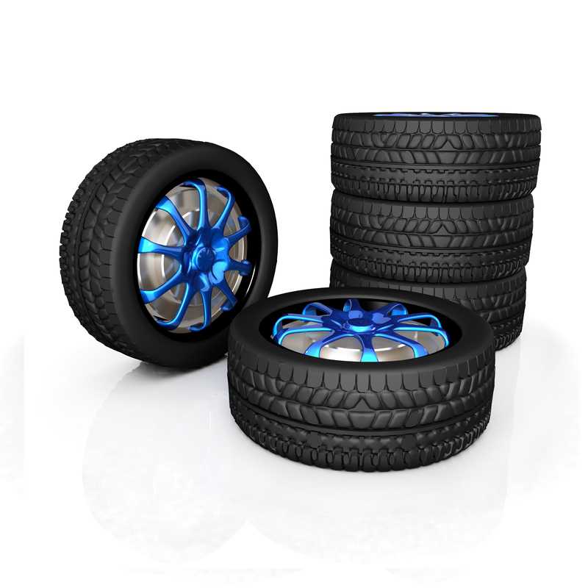

Pinewood Derby Skit
This skit has been performed by Webelos Scouts as they have been through this a few times.
SL: What was your favorite pinewood derby car last year?
#1: Someone drilled holes in one, painted it yellow, and called it cheese.
#2: A Scout painted their white and made it look like a Wii Remote.
#3: The one that looked like a skateboard.
#4: The hotdog car was cool. I think they used real ketchup and mustard.
All the Webelos start talking at the same time: The Batman car looked like a plane. The rocket car. The fireball.
DL: What have you learned about building Pinewood Derby cars?
#1: I forgot to glue the axles, and the wheels came off.
#2: I cut too much wood off and had 14 pennies taped to mine.
#3: My dad used some special lubricant and mine was rejected.
#4: I spray painted my hand blue last year (shows their hand that's still blue).
#5: Not to build it the night before.
DL: What do you like best about the Pinewood Derby?
#1: The day of the race and all the races.
#2: Building the cars.
#3: Spending time with my dad.
#4: Going to the hospital.
DL: What do you mean going to the hospital?
#4: Every year, my dad tries something new with a new tool he just bought from Home Depot, and every year, we end up in the emergency room. Ain’t that right dad?”
All dads in the Webelos den do their best grunting imitation of Tim “The Tool Man” Taylor from the TV series, Home Improvement: "RRRR, RRR, RRR, that's right."

Who Am I?
Need: 8 actors – one for the narrator and one to deliver each verse. Make a placard for each verse (small for the Cub Scout to read) and with the famous person’s name large enough for the audience to read. (Shown here in parentheses).
After the actor has delivered their verse, and allowed a short time for the audience to guess the subject, the actor turns over the card to reveal the name on the placard.
The Narrator recites the first two verses. No costumes or scenery are required.
Narrator: Transportation through the years Has changed, we are aware. Because some men had a vision, and were not afraid to dare. Although we see the evidence of all that they have done,
Let’s see if you can guess their names Presented, one by one.
# 1: Until I came along and helped, fat boats were just a dream. For I got rid of sails and oars; I gave the boat its steam! Who am I? (Robert Fulton)
# 2: I gave life its “ups and downs” so many men would say the elevator makes tall buildings possible today! Who am I? (Elisha Otis)
# 3: As people peddle down the street, From grannies to little tykes, they all owe me a debt of thanks, ‘cause I invented bikes! Who am I? (Pierre Lallement)
# 4: As trains crisscross the continents, My humble head is bowed. “Father of the locomotive” is the name of which I’m proud! Who am I? (George Stephenson)
# 5: As soon as you say “airplane,” Our names quickly come to mind: But when we started, pilots were Quite difficult to find! Who are we? (Orville and Wilbur Wright)
# 6: ‘Though I did not invent it, I played a major part in mass-producing autos. I’d say I gave the car its start! Who am I? (Henry Ford)
# 7: I’ll have a fuel-less motor that will hit the marketplace, And stop pollution of all kinds And go faster into space. Who am I? (YOU?)

CUB GRUB

Table tents available at www.shac.org/pinewood-derby.

Food ideas available at www.pinterest.com/samhoustonbsa/pinewood-derby.

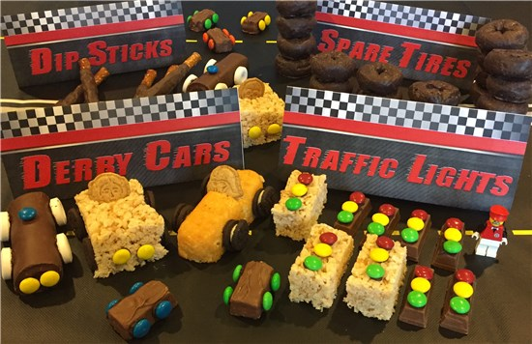

GAMES

Auto Trip Musical Chairs
Players are seated in a circle and each one is given the name of a part of a car (tires, gas tank, hood, steering wheel, tires, brakes.) One player begins as the storyteller, including various parts as they tells the story of the “trip.” “We went down the road till a Tire went flat…” As a car part is mentioned, the player with that part gets up and runs around their chair, then sits back down. (It helps the storyteller to have the car parts listed on the wall) The story continues, with the storyteller sometimes yelling “Blowout!” Then everyone, including the storyteller must leave their seat, race around the circle and find a different seat. Meanwhile, the den leader pulls one chair out of the circle. Whichever player is left without a seat becomes the new storyteller.

Back-To-Back Relay
Two Cub Scouts stand back to back with their backs touching. They run together from the starting line to the finish line, with one Cub Scout facing forward and the other facing backward during the run. Then on the return, the one facing forward faces backwards. They must always keep their back touching.

Broken Down Car Relay
Divide the Cub Scouts into two or more teams of eight Cub Scouts.
Line them up single file at a starting point. You can make up other problems and actions for the Cub Scouts to do.
1st: The first player one each team represents a flat tire. They hop to the goal and back.
2nd: The second player is a broken radiator. They make a hissing sound as they run to the goal and back.
3rd: The third player has water in their tank. They walk forward three steps and backward two steps until they have covered the course.
4th: The fourth player has a rundown battery, so the 5th pushes him.
6th: The sixth player lost their wheel. They move on two hands and one foot.
7th: The seventh player can only move in reverse; so they run backward.
8th: And the eighth player is in good shape. They run fast!

Bulls-Eye Race
Preparation:
- Make a track out of one 8-foot length of 6" wide x 3/4” thick plywood board.
- Use the traditional strip of wood running the length of the board for the lane.
- Paint 1-inch strips across the board every 6 inches in different colors (Red, yellow, blue, green, etc.) before you attach the center strip.
- Cut a 36x36” piece of butcher paper. Draw a bulls-eye on the paper using 6-inch wide rings.
- Give each ring a point value.
- Tape the bulls-eye flat to the floor.
- Raise the track a few feet off the floor. (The track could be braced on the seat of a chair.)

Car Tire Games
Find It on A Map: Give each team a United States map. Have the first Cub Scout from each team step up to the map and you call out a city. The Cub Scouts all get a predetermined time to find the city and whoever does gets a point (or only the team of the first Cub Scout to find the city gets the point.). Once the Cub Scout has found it, they get one point for their team and the next Cub Scout steps up to the map. Call out another city. This continues until one team has 11 points.
Geography Game: Players are seated in a circle. First player names a geographical term — city, river, country, animal, race, etc. Second person must give a geographical word which begins with the last letter of the first player's word. Continue thus around the circle. The same word is not to be given twice.
I Pack My Suitcase: One Cub Scout starts the game by saying "I pack my suitcase and I put in (he says something like my shirt., or my toothbrush). The next player says I pack my suitcase and I put in…repeats the first player's item and then adds their own. This continues and each Cub Scout who is not able to get all the previous items correctly is out of the game and The game continues until all but one Cub Scout have missed.
Moving Target: Players take two turns rolling tire parallel to other players 15 – 20 feet away who try to throw balls or beanbags or broomsticks through the tire as it rolls by.
Plot Your Route: Give each Cub Scout a state map. Tell them you are leaving this city (where you live or meet) and going to (another city in the state). Have them plot the route you will need to take.
Roll for Distance: Each player rolls their tire separately and is entitled to run to gain speed and momentum but must stop at the stopping line while the tire rolls forward by itself.
Roll for Accuracy; Same as above, except tire is rolled at a target of 2 sticks set 3-4 feet apart and approximately 20 feet away.
Tire Sprint: Racers line up with forward edge of tire at the starting line. On signal, they push tire forward and continue to push it across finish line. If necessary, establish lanes.
Tire Wrestling: Place two tires on the ground so they touch each other. One contestant stands in each tire. As the signal, they wrestle to throw or push their opponent out of their tire. The winner is the first to cause the other to fall or step out of their tire, provided they remain on their feet in the tire.
Tire Bowling: Bowl, using discarded tires in place of balls, with milk cartons or tin cans for bowling pins. Arrange “alley” on the ground with the bowling line 20 – 30 feet from the pins. Each bowler rolls two tires. Score as in bowling. Or use discarded tires in place of a ball and milk cartons, tin cans, or bleach containers for pins. Arrange “alley” on the ground with the bowling line 20 to 30 feet from the “pins”. Each bowler rolls two tires. Score as in bowling.
Tire Rolling Relay: Form teams and give the first player of each team a tire. Place a stake or chair opposite each team on the turning line. At the signal, the first player rolls their tire to the turning line, rolls it around the stake and back to the next player in line.
Through the Tire Relay: Establish a rolling line in front of the lines of dens. The first player of each team goes up to the rolling line with a tire. At the signal, they roll their tire forward toward their team by giving it one shove. The players in turn then straddle-jump the tire. If the roller did not steer the tire exactly straight, the line must shift in order to be in line with their tire. If a player knocks the tire down in attempting to jump it, or if it falls over before they can jump it, they must recover the tire and give it to the player in front of them who rolls it for them and the rest of the team. The original roller then takes place at the front of the line. When the last man has jumped the tire, they roll it to the starting line, and the action is repeated until the original roller has rolled the tire back to the starting line.
You're Going to Take a Trip: For this game you will need two teams of three or more Cub Scouts. Each Cub Scout has blindfold so that they cannot see. One Cub Scout will be the leader of their team and will have to guide their teammates and pick up small flags along the way. (The Webelos leader has put these markers in the back yard ahead of time so that no one will know where they are.). Make two identical trails. The team that comes back with the most markers is the winner.

Car & Driver
Cub Scouts work in pairs. One partner is the driver and stands directly behind the other with their hands on their partner’s shoulders. They walk through a course that has been set up previously. Use tape on the floor or signs to indicate making a turn, stopping for signals, taking a detour, etc. Begin with eyes open, but the “driver” can only direct their “car” by using their hands on the shoulders. After doing the course with eyes open, try it with the “car” having a blindfold or closed eyes, directed only by the “driver’s” voice. To make it even more challenging, have the vehicles cross over each other’s paths!

Great Race
Materials: tape to make the track.
Using a piece of wide, nonsticking adhesive tape (painters tape is the easiest to remove), make a straight line for each den on the floor. The line should be about 10 feet in length and 3 inches wide. This becomes the race track. Cub Scouts walk the length of the tape as the den leaders watch to make sure they stay on the track. After all have reached the end of the race track, change the manner in which the Cub Scouts go down the track: walking with a book on the head, walking backward, hopping on one foot, hands on their heads, hands behind their backs, and more.

License Plate Tag
Materials: small pieces of duct tape and prepared license plates (Write a combination of numbers and letters like “TMC35” and “98PB” on 4×6-inch index cards, some with blue pens and some with black. Make a dozen or so in each color. The two colored sets must have the same number of plates but the numbers do not need to be identical.)
Divide Cub Scouts into “blue” and “black” teams. Each Cub Scout wears a license plate on their back attached with a piece of duct tape. The object of the game is to read aloud the plates of the opposite team while trying to keep your team’s plates hidden from view. A player whose plate has been read goes back to their team’s base and gets a new one. Continue until one team runs out of plates. Variation: Players try to snatch the plates instead of reading them.

Race:
Cub Scouts hold their pinewood derby cars at any starting line they wish (e.g., the yellow stripe) and then let it go.
The Object:
- The object is to have the car stop in the bulls-eye.
- If the car stops short, the Cub Scout should start their car higher up on the track.
- If the car rolls too far, they should start it on a lower stripe. Each Cub Scout gets two trial runs and then a scoring run.
- Points are awarded depending on where the car stops.

Transportation Charades
Before the meeting, write down different modes of transportation on slips of paper. To play the game, each Cub Scout (younger Scouts will need the help of their adult partners) acts out one type of transportation while the others guess what it is.

Red Light, Green Light
Materials: STOP and GO signs and rope for finish line (Signs are easily made by writing the word on construction paper; tape a pencil to the back for stability.)
- Cub Scouts line up on one side of the yard; den chief stands at the finish line on the other side.
- When the den chief holds up the GO sign, the Cub Scouts may move toward the finish line.
- When the Den Chief raises the STOP sign, Cub Scouts must stop in their tracks.
- If they don’t stop, they must go back to the start position.

Wheels
Have a group of Cub Scouts stand in a horizontal line with space ahead of them to run. Give each Cub Scout a number in direct sequence, starting with 1. Then shout out different modes of ground transportation—car, train, bicycle, etc. Each time, the Cub Scout whose number matches the number of wheels will run to the other side and back to the starting line. For example, if you shout “bicycle,” number 2 runs, car = 4, three bicycles = 6, unicycle = 1, etc. If you shout “train,” the whole group runs.

Box mobile Derby
This is a fun game where Tiger Cubs in their Box Cars “drive” from pit stop to pit stop trying to accomplish each task. Use your imagination to come up with pit stop ideas! Some Pit Stop Ideas:
- Staying in Your Lane: Tiger Cubs walk the edge of a wooden board or a taped line on the floor. If a Cub Scout strays out of their lane, they have to return to the start and try again.
- Backing into a Parking Space: Tape a balloon to the wall and have Tiger Cubs back into it until it pops.
- Washing the Windshield: Have a damp washcloth hanging from a string. Tiger Cubs mush wash the windshield (their faces) with using their hands.
- Singing with the Radio: Tiger Cubs stop and sing any song as if they were singing with the radio.
- Gassing Up the Car: Have a small (8-oz. or less) glass of water for each Cub Scout to drink as they come through this pit stop.
- Changing Tires: Have Tiger Cubs take off their old tires (shoes) and put on new (adult sized) tires before racing down a path and back. Then they put their original tires back on.

Going on a Trip
Equipment for each team: one suitcase filled with a hat, coat, gloves, and any other desired clothing, one umbrella. (Keep the contents of the suitcases uniform in components and fastenings).
At a signal, first player from each team runs to the goal, opens the suitcase, puts on clothes, closes suitcase, opens umbrella and runs to starting point. There, they take off all the items and player #2 puts them on. Player #2 races to the suitcase, undresses, repacks the suitcase and returns to the team. # 3 starts the process over, comes back and gives the items to #4, etc. This continues until each player has dressed. First team completed wins.

Grand Prix Race
Equipment: 2’ x 2’ piece of cardboard for each team; cones and other objects
Preparation: Set up cones and objects to create a track. Divide Cub Scouts into teams of two. Each team is given a car (2 x 2 piece of cardboard).
The Race: One Cub Scout from each team sits on the cardboard and scoots around a predetermined race track using their feet and hands. When they complete the course, the second Cub Scout on the team takes their turn.
I Am Part of an Automobile
With players seated in a circle, someone starts off by saying, “I am a .” and gives the name of some part of an automobile. The idea is to see how long you can keep going around the circle until you run out of parts. As long as one is able to name a new part, they may remain in the game. Keep going until only one is left in the circle. No part may be named twice.

Jet Car
Materials: 2” x 2” x 5” box, 9” balloon, 2 straws 1 ½” long,
straw 4” long, wooden dowels 3” long and 1/8” in diameter, 4 milk bottle caps or other lightweight wheels, 2 rubber bands,
masking tape, hammer and small nail.
Construction: Tape the two short straws on the bottom of the box to house the dowel axles. Make a small hold in the center of each bottle cap wheel with the hammer and nail. Force one wheel onto each axle. Wheels should fit tightly. Put each axle through a straw on the box bottom and attach the other two wheels. Insert the long straw section into the neck of the balloon about ¾”. Secure with a rubber band. Poke holes in the box so that the straw can mounted at an angle, aiming at the floor. Secure with a rubber band.
Use: Blow through the straw to inflate the balloon. Pinch off the straw to trap the air. Set the car on the floor and let it go.

Oops, the Tires Are Flat
(Simple ring toss game)
Materials: Rings (canning jar rings, ring toss rings, etc.). One set of four rings for each set of “car tires.” Four “car tires” (2-liter bottles, toy bowling pins, marking cones, etc.). The number of sets will de- pend on the size of your pack.
Instructions: Set up the “car tires” to look like the tires on a car—two of them side by side about 2 feet apart, then the second two the same distance apart, but about 3 feet over from the first set. They should create a rectangle when placed. (See below.)

0 0

0 0

CM: “The tires have gone flat on our race car, and the Cub Scout must get all four tires changed to get us back in the race.”
Decide how far back you want the Cub Scouts to stand. When the first Scout is ready, have them toss the rings until they have one on each of the “tires.” Once they have a ring on each of the four tires, the next Cub Scout plays.

Ready, Aim, Roll
Materials needed:
Two old rubber tires and several tennis or ping pong balls.
Directions: Divide the group into two teams. Have the teams form two lines about 15 feet from the tires. The tires can be standing up or lying flat on the ground. Each player gets a chance to throw one or more balls into the tire. Remind them about ricochet. Each ball that lands in the tire if it is flat, or that goes through the tire standing up earns the team a point. The team with the most points wins.

Start Your Engines
Arrange the Cub Scouts in a circle, with one Cub Scout in the center. Each Cub Scout chooses the name of a car they would like to be. It can be the make of a vehicle such as Ford; or it can be a specific model like Explorer. The Cub Scout in the middle starts the game by saying “I would like to drive a Honda.” They can say any car that the Cub Scouts have chosen. Now the “Honda” player needs to answer “I’d rather drive a ” filling in another name of a car. Play continues until a person chooses a car that doesn’t belong, or is their own car. They then go into the center and play starts over. You can also change it so that the player that misses is out and play the game elimination style.

Stock Car Racing
Active, indoors/outdoors - No equipment
The Cub Scouts line up in lines. Each Cub Scout is given the name of a car and when that car is called, they travel to the end of the area and back in the manner described
Examples are:
- Rolls-Royce – this never goes wrong – the Cub Scout runs
- Austin - has a flat tire – the Cub Scout hops
- Morris – stuck in reverse – the Cub Scout runs backwards
- Ford – very old model, can only go slowly, the Cub Scout walks
- Mini – it’s a small car – the Cub Scout runs, crouched down
- Hummer – pulls caravan, the Cub Scout tows their den behind When “Stock Car” is called – everyone runs
Make up the car names and actions as you wish

Tire Grand Prix
Lay out a course in a safe, open area, and give each player an old tire. Then have players race, rolling their tires around the course. At each “pit stop” the driver passes the tire on to a fresh driver.
For added fun, allow player to kick, knock over, or in any way impede the progress of the opposing racers, while still trying to get their best time.
Alert safety guards to watch for unnecessary roughness. Old tires can be borrowed, which alleviates the disposal problem after the race.

Whirling Wheels
Equipment: 1 beanbag per Den.
Arrange the dens like the spokes of a wheel, facing in a clockwise direction with the Denner in the center. A beanbag lies at the feet of each Denner. When the leader gives the starting signal, The Denner Picks up their beanbag, runs down the line of their den and runs in a clockwise direction around the wheel and Back to the outside end of the den. The beanbag is then passed up the den to the Cub Scout now at the center. This continues until all the Cub Scouts have had a turn.

Car Relay
Divide your Cub Scouts into teams of 6 and have them each select the part of an automobile they will be. Then tell them how they will race.
- Steering – gear is broken – walk zigzag.
- Flat tire –Limp.
- Gas Tank – water in tank two steps forward, one step back.
- Transmission – Can’t go forward – walks backward.
- Battery – Dead – can’t go at all (See Tow)
- Tow – Pushes 5th player by placing both hands on player’s waist.

CUBMASTER MINUTES

Do Your Best
When you give the Scout Oath, the words “Do your Best” are often lost among all the other very important words. Let’s stop for a minute and carefully consider these words. Best describes effort and action above our usual performances. You are the only person who can possibly know whether or not you have done your best. Every time you repeat the Scout Oath, you agree to do your best. Your best is just that: The very best that you can do. Think about the meaning of the Scout Oath that you repeated at the beginning of the pack meeting. Decide that you will always do your best, no matter what the job is that is facing you.

Henry Ford
Henry Ford is certainly an example of positive attitude. He built his first vehicle, called the Quadricycle in 1896, and with two other investors founded the Detroit Automobile Company in 1899. But that company folded in 1900. Then in November of 1901, along with five other investors, he started the Henry Ford Motor Company. But after only four months, he left or was forced out of that company. When he left, he took with him his tools and rights to his name. In 1903, he again started the Ford Motor Company. He continued to work on new models and techniques, even visiting other countries to see their methods. In 1909, Henry Ford finally produced the “Model T” - a basic, sturdy, inexpensive car that was reliable and available to the ordinary family. But he kept on looking for even better designs and cheaper, more efficient methods. He introduced the moving assembly line in 1913, and by 1925, his basic car reached the unbelievable low price of only $260. He had set himself the goal to produce a basic, sturdy, reliable vehicle, and in spite of the failure of his first two companies and many design and production challenges, he kept a positive attitude and met his goal. Cub Scouts, too, have goals to reach – some they choose for themselves and some are requirements for advancement. And in spite of challenges, they can learn to keep a positive attitude and keep focused on their goal. Let’s make sure that we as adults also model a positive attitude when we play and work with Cub Scouts – keep focused on your goal!

Keeping Fit
Cub Scouts, I hold in my hand a pocketknife. This is a valuable tool because it can be used for many useful things. (I used this one to help carve my son's Pinewood Derby car for tonight's race.) It is a dependable tool as long as the blade is kept sharp and free from rust and the working parts are in good condition. But, if it is neglected and becomes dull and rusty, it can be a dangerous tool.
The same principle can be applied to ourselves. We have a body, which when kept in good condition, will serve us well. If we get plenty of exercise, eat the proper foods, and have good health habits, we will be able to enjoy to the fullest the things we do. But if we fail to take care of ourselves, we can become rusty and dull like the neglected knife. Do your best to keep fit!

Models for the Future
The Cubmaster shows a model of a futuristic car and says: Cub Scouts, here is a great looking car. It is the builder's vision of what cars may look like in the future. We can't be sure that he's right. But we can be sure that the world is going to need good men in the future. And we can be sure that we will all be good men if we remember to follow the Scout Law and Scout Oath. Let's remember that as we stand and repeat the Scout Law (or Scout Oath).

Our Pinewood Derby
At the conclusion of our Pinewood Derby I would like to say that we were all winners here tonight. Dad has more respect for their child whether they were a humble winner or a graceful loser. Mom was proud of her child whether she gave them a hug of congratulations or comfort. The Cub Scouts gained a better knowledge of competition; how to win, how to lose, how to be happy for a friend, who is taking home the trophy they wanted so badly. The leaders, in the pride they felt knowing that each of their Cub Scouts had done their best. Building the car helped bring families closer together. No, there are only winners here tonight. Thank you all for helping to make the pack go and the Cub Scouts grow. Good night and congratulations to all of us winners.

Pinewood Derby
Winning isn’t everything. It sure is nice to be a winner at a sport, a game of chance, or even a great race! It feels good inside to be the best at something on that given day. But, unfortunately, only one of us can win at any given event on any day. Maybe you didn’t sleep well the night before, maybe you had a cold last week and are just recovering, or maybe you’re just not all that good at the event. If you were the winner, then enjoy the fact that you won— quietly and graciously. If you didn’t, here’s something to think about: Did you Do Your Best? Did you try hard? Did you prepare, and did you support your team? If you can answer yes to all of these, then you are a winner in your own way for simply doing the best that you can. Learn what you can from any mistakes, and take pride that you did your best!
Tires
Hold up a tire advertisement. Cub Scouts, tire manufacturers are constantly working to make a better tire; one that can withstand the pounding and abuse that high-speed driving demands. In other words, a tire that “can take it”. Like the tire, you and I are put to the test every day. When things are going along smoothly, it’s not hard to get along. The real test is how we’ll do when the going gets rough; when things do not turn out the way we want them to. At times like these, the Scout Oath and Law can help you carry on with the right attitude and do your share without grumbling or griping. It will help you meet the test. Can you take it?

Trustworthy
“We have seen that being trustworthy is important to our success in the great Cub Scout race and each stage of our lives. By being steadfast and honest, we can overcome any barrier or mistake and celebrate when we see the checkered flag at the end of every race we run.” Wave a checkered flag.

You Have a Choice
You have a choice.
You can be pleasant or unpleasant. Which do you choose?
You can be grouchy and grumpy or you can be happy and cheerful. Which would you rather be? It is up to you. Tonight, we’re all winners.
We had fun and enjoyed each other’s company. Let’s take that warm feeling of friendship home and keep it close to our hearts until our meeting next month!

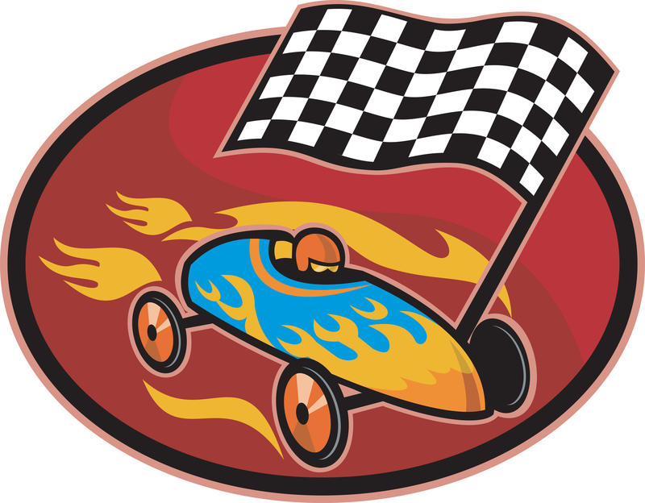

CLOSING CEREMONIES

Car Fun
Personnel: Six Cub Scouts
Equipment: Pictures of the vehicles named by the Cub Scouts
Setting: Cub Scouts holding pictures as they recite or read lines.
# 1: I have fun riding in my dad's convertible on sunny days.
# 2: It is exciting to go back country in our Jeep (or other SUV).
# 3: Riding in our street rod in a parade is my thing.
# 4: Taking our camper (or Recreational Vehicle) out for a week in the woods is our family's favorite vacation.
# 5: Taking the den on a field trip in the minivan lets us watch a movie on the way.
# 6: As you can see, there are many ways to have fun in cars, just as there are many ways to enjoy Cub Scouting.

Patriotic Closing
Equipment: A small American Flag for each Cub Scout, cue cards.
Set Up – Eight Cub Scouts in uniform stand in a straight line, each holding an American Flag and their cards
# 1: I am the symbol of the living America, the badge of its greatness, the emblem of its destiny.
# 2: I am faith. It is I who keep men mindful of their priceless heritage…life, liberty, and the right to pursue happiness.
# 3: I am hope. I represent the land of promise where in, already, man’s loftiest dreams have approached closer to realization than ever before on this earth.
# 4: I am life. Each strand and fiber of my being is a memorial, dedicated to the sacrifices of all those strong men and steadfast women who have lived and died in the nation’s service, that it might live longer.
# 5: I am tolerance. So long as I shall wave, all people under my protection may freely worship, think, write and speak, undaunted by the shadow of fear.
# 6: I am justice, tempered with mercy. For I am friend to the oppressed and downtrodden of every land.
# 7: I am a sign of the future. I wave over schools throughout the nation and in them the nation’s future is molded.
# 8: I am the flag of the United States…the last….the best hope for peace on earth.

Pinewood Derby Closing Ceremony
Materials: lines for each Cub Scout, written in large print on separate index cards
#1: It has been many years since Baden-Powell
founded Cub Scouting.
#2: He formed a program for us to learn and have fun.
#3: Tonight, we have shown you some of the things
we’ve learned.
#4: We’ve shown you citizenship.
#5: We’ve shown you creativity.
#6: We’ve shown you family fun.
#7: We’ve shown you how we run the great race.
#8: Now we’ll show you that we can be good.
All: Good night. (Cub Scouts retrieve the colors.)

Pinewood Derby Closing
Form a circle around the derby track
CM: "Coming together is a beginning. Keeping together is progress. Working together is success.” This is a quote from the famous carmaker, Henry Ford. All of the dens come together to form the beginning of our pack. Keeping together at our monthly pack meeting is progress. Working together in Cub Scouting is surely a success story of which you can have a great part. Let's remember this in the coming months. Please repeat with me the Scout Law. Thanks for coming out for our Pinewood Derby tonight. We've worked together and made ever Cub Scout in Pack ____ a winner!

Pinewood Derby Conclusion
Cubmaster: At the conclusion of our pinewood derby, I would like to say that we were all winners here tonight.
# 1: Dad has more respect for their child whether they were a humble winner or a graceful loser.
# 2: Mom was proud of her child whether she gave them a hug of congratulations or comfort.
# 3: The Cub Scouts gained a better knowledge of competition; how to win, how to lose, how to be happy for a friend, who is taking home the trophy they themself wanted so badly.
# 4: The leaders, in the pride they felt knowing that each of their Cub Scouts had done their best.
# 5: Building the car helped bring families closer together.
CM: Yes, there are only winners here tonight. Thank you all for helping to make the pack go and the Cub Scouts grow. Good night and congratulations to all of us winners.

We Are All Pinewood Derby Winners
Have the winners of the various trophies stand and be recognized one more time. Ask the Cub Scouts who are not yet standing to come forward and lead the Pack in the Scout Law or Scout Oath, as they, too are winners, because they “did their best.”

Race Steward’s Cheer
Equipment: Solid green flag and black-and-white checkered flag
# 1: In racing this green flag means go.
# 2: And this checkered flag means that the races for today are over. We’d like to lead you in a cheer for all the racers tonight.
# 3: Are you ready?... Get set… Cheer! Wave the green flag for 5 seconds while everyone cheers; then waves the checkered flag for everyone to stop.
Do this a few times and then wave the checkered flag a final time to indicate that the meeting is over.
CM: Good night, everyone.

Travel Closing
Props: Draw appropriate pictures or use models or photographs of the items mentioned.
# 1: (Train engine) When engineering a project keep on the right track. This way you never will be caught slack.
# 2: (Covered wagon) The covered wagon served folks well in its day. But don't get in a rut, you won't get far that way.
# 3: (Automobile) If spinning your wheels causes a terrible rumble, you may not be moving -just sitting there grumbling.
All: Just like the cars in a train We're joined together as one.

We do our best to help the pack go While having Cub Scout fun.
And when it's time to part and each take a separate trail,
We'll do our best for God and country. In that we will not fail.

DECORATIONS

SOCIAL MEDIA POSTERS

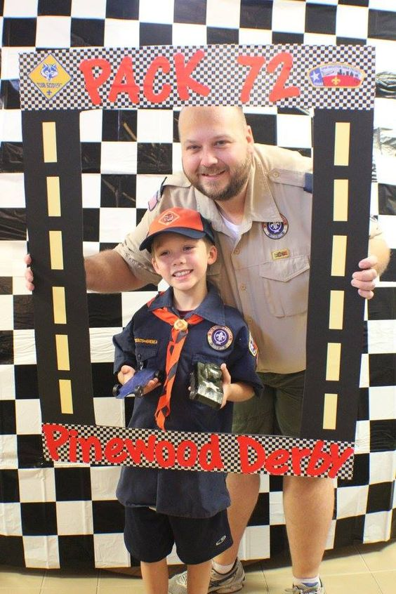

THEME RELATED IDEAS

- Host a car-building workshop. Ask an adult to open their workshop/garage to assist Cub Scouts with limited resources to assistance with design, cutting, and finishing the cars. Have extra parts available.
- Work on advancements. Make car stands or display cases as den projects.
- Bear - BALOO the Builder
- Webelos Scout: Build It
  - Check with local race drivers to see if you can borrow official racing gear for the derby. Also check with the Federal Highway Safety Administration or State Highway Patrol to see if they have crash dummy costumes to borrow.
  - Invite a local celebrity or two (mayor, politician, policeman, minister, weatherman, race car driver, etc.) to make a race car and race it against the Cub Scouts or in an adult race. They could also serve as race officials or judges of best design competitions.
  - Feature an adults or open class race for parents, leaders, siblings, etc. to allow them to race. Why should the Cub Scouts have all the fun?
  - Hold a carnival to keep Cub Scouts busy. Ask the Bear den to sponsor the carnival as they work the Grin and Bear It Adventure.
  - Add extra pizzazz with racing decorations (e.g., checkered flags).
  - Have someone photograph each Scout posing with their car with an appropriate background (trophies, banners, flags, etc.).
  - After the race, let the Cub Scouts use their cars in a special event like a target race (roll the car towards a target to see who gets the closest).
  - Make each Cub Scout a driver’s license.
  - Add a special station to have the Cub Scouts take an eye test or written exam prior to getting their driver’s license.
  - Consider seeing if a car dealer or auto parts store will help sponsor your derby. You may want to run your derby in conjunction with an auto show.
  - Have other awards or certificates to present to who did not win their races.
  - If you have someone in the pack with a good voice (don’t forget siblings or parents as well), have them lead the singing of the National Anthem at the start of the race.

MEETING HANDOUT

Edit the text boxes on the next two pages. An editable, word version of this document is available at www.shac.org/pinewood-derby-theme.
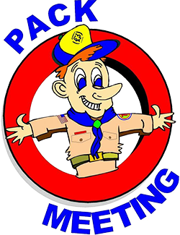
- Page 1: insert pack number and month/year
- Page 2: list detailed announcements, edit upcoming events for next three to six months, customize electronic communications.

Print one copy per person (of next two pages), one-sided to two-sided

Announcements: During meetings, keep announcement very short. Having detailed announcements printed in the handout saves times during meetings and avoids the dreaded long announcements that run on and on (that nobody can hear, nobody pays attention too and Scouts dislike). Encourage the parents to put the handout on their refrigerator. Parents will get used to getting a handout at each pack meeting.

Songs: have more songs than you think you need. You don’t have to sing them all, but having a back-up in case of a lull in the program is always helpful.

 | Pack <#> |  |  | 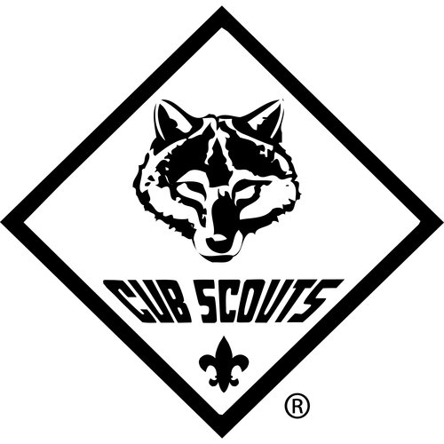 | <month year>
The Pinewood Plea  Tune: My Bonnie Lies Over the Ocean  My dad, he cut out my racecar  He put all the wheels on himself  My dad then sanded the car smooth  And put it up high on a shelf!  Give back, give back,  Give back my car kit to me, to me!  Give back, give back,  Oh, give back my car kit to me!  My mom took the car of the shelf,  And painted the car all by herself,  She added a cute Cub Scout driver,  And put it right back on the shelf!  Give back, give back,  Give back my car kit to me, to me!  Give back, give back,  Oh, give back my car kit to me!  So, I went and bought my own car kit,  And did the car up myself,  I won first place at the derby  And put the award on my shelf! |  | 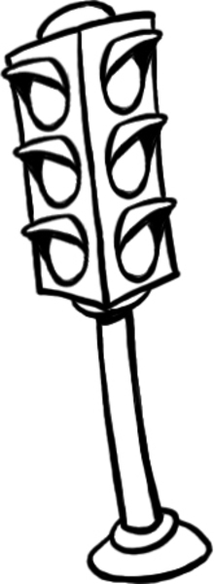  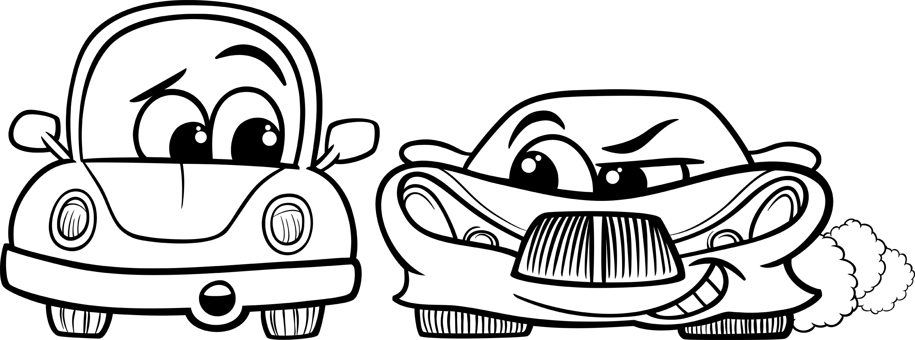 |  |  |  |  | 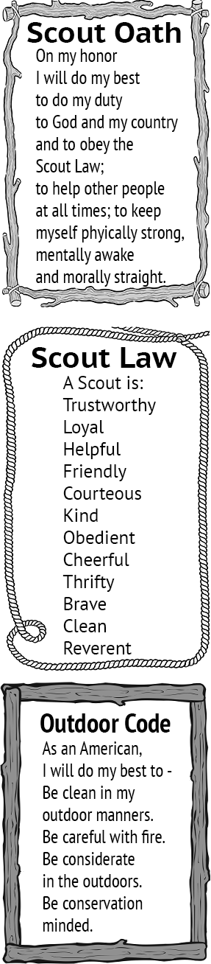
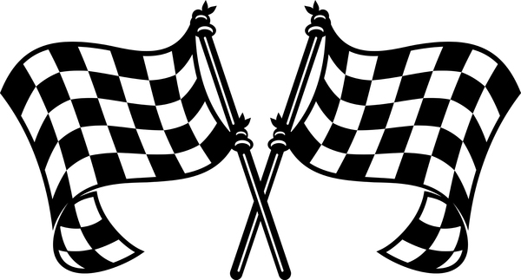  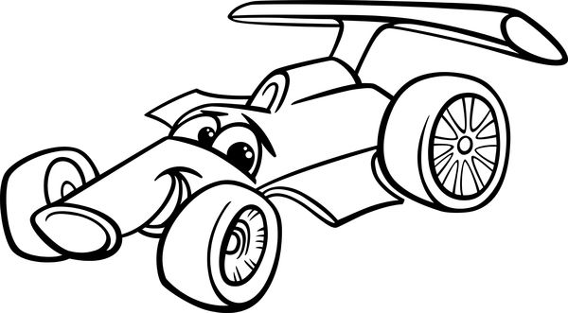 |  |  | Tom the Toad at the Pinewood Derby  Tune: O, Christmas Tree  O, Tom the toad, O, Tom the toad,  Don't rest on the Derby Road  O, Tom the toad, O, Tom the toad,  Don't rest on the Derby Road  The cars are coming straight and fast,  If you rest there, you will not last!  O, Tom the toad, O, Tom the toad,  Hop around the Derby Road.  O, Jake the Snake, O, Jake the snake,  My pinewood car, it has no brake.  O, Jake the snake, O, Jake the snake,  My pinewood car, it has no brake.  If you lie on the finish line,  The cars will come and crush your spine!  O, Jake the snake, O, Jake the snake,  Why don't you crawl back to the lake?  O, Mack the yak, O, Mack the yak,  Get up off our derby track.  O, Mack the yak, O, Mack the yak,  Get up off our derby track.  Though you're big, there is no doubt,  A car could still knock your eye out!  O, Mack the yak, O, Mack the yak,  Get up off our derby track

 | 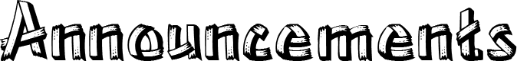
<insert announcements> |  |  |  | Upcoming Events  <Month Year>  <day> <event>  <day> <Den meeting>  <day> <Pack meeting>  <day> <District event>  <day> <Council event>  <Month Year>  <day> <event>  <day> <Den meeting>  <day> <Pack meeting>  <day> <District event>  <day> <Council event>  <Month Year>  <day> <event>  <day> <Den meeting>  <day> <Pack meeting>  <day> <District event>  <day> <Council event>  <Month Year>  <day> <event>  <day> <Den meeting>  <day> <Pack meeting>  <day> <District event>  <day> <Council event>  <Month Year>  <day> <event>  <day> <Den meeting>  <day> <Pack meeting>  <day> <District event>  <day> <Council event>
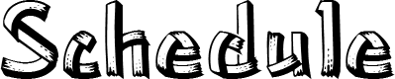  <insert pinewood derby schedule> |  | Pack <#>  facebook.com/<insert URL>  <pack website>  <insert> District  <district website>  facebook.com/<insert URL>  Sam Houston Area Council  www.shac.org  facebook.com/shac.bsa

